## [Is La Niña giving us the best prawns ever for Christmas lunch this year?](https://www.delicious.com.au/food-files/news-articles/article/la-nina-giving-us-best-prawns-ever-christmas/77cjjddq)



* Khi nhấp vào hình ảnh or chữ



**Why this festive season is set to be shrimply the best.**

An Aussie Christmas without prawns is like a margarita without salt – it’s just not the same. Luckily for us, there’s a positive to the record rainfall we’ve been seeing across the east coast of Australia.

So, what exactly is the upside to [La Niña](https://www.delicious.com.au/food-files/news-articles/gallery/why-interest-rates-la-nina-making-grocery-prices-higher/29946zt0), we hear you ask. The answer? A bumper prawn season.

“Prawns rely on rainfall on the land to source their food, and the heavy rainfall we’ve experienced across the east coast has flushed high levels of nutrients into their environment,” says Sydney Fish Market tour guide and resident seafood expert Alex Stollznow. According to Stollznow, the heavy rain will result in juicer and tastier prawns.

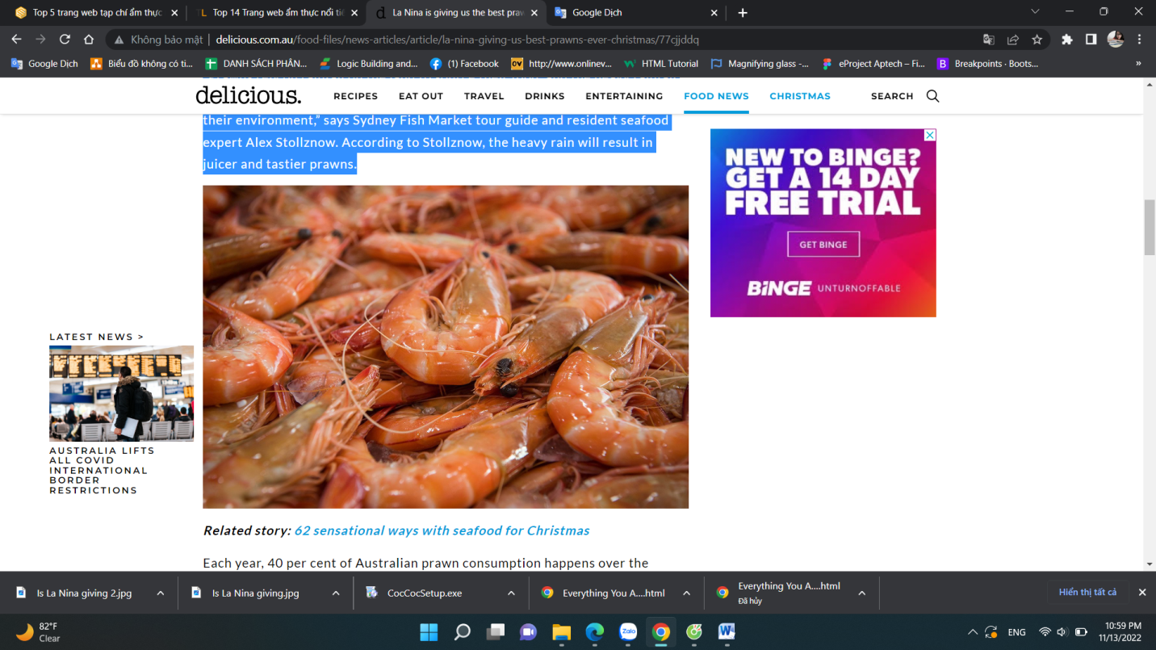

Each year, 40 per cent of Australian prawn consumption happens over the Christmas period. So, when the [Sydney Fish Market](https://www.sydneyfishmarket.com.au/) opens its doors for its 36-hour seafood marathon (from 5am 23rd December to 5pm Christmas Eve), over 130 tonnes of prawns are expected to be sold.

Which can only mean one thing for those donning an apron during the festive season – it’s time to get shellfish.

Start by bringing back the good old [prawn cocktail](https://www.delicious.com.au/recipes/barbecued-prawn-cocktail-recipe/dbk6idgl), but let that just be the beginning – [salt and pepper prawns](https://www.delicious.com.au/recipes/salt-pepper-prawns-pineapple-dipping-sauce/76bd786c-5ca0-4b77-bdd2-8ad987b53edf?current_section=recipes&r=recipes/collections/prawnrecipes&c=d7e4388b-01bc-41e6-b840-0c9bd24064fc/prawn%20recipes) are always a crowd pleaser and our favourite crustaceans also make a [pretty mean salad](https://www.delicious.com.au/recipes/prawn-fattoush-salad/771b47bf-39b1-4cff-8866-94d7742fc799?current_section=recipes&r=recipes/collections/prawnrecipes&c=d7e4388b-01bc-41e6-b840-0c9bd24064fc/prawn%20recipes).



And if you feel like you’re prawn to be wild, it’s definitely worth starting your day with this stellar recipe for [prawns on toast](https://www.delicious.com.au/recipes/prawns-toast-lemon-myrtle-mayonnaise/de22312f-aabf-449a-a80e-8f41f6774dcd?current_section=recipes&r=recipes/collections/prawnrecipes&c=d7e4388b-01bc-41e6-b840-0c9bd24064fc/prawn%20recipes) (with a distinctly Aussie twist).

There’s more good news too. Having a prawn feast this year won’t break the bank. “If pricing is a key consideration for you, consider choosing a species like the school prawn, which will offer the same great taste for a more competitive price,” advises Stollznow.

Little [school prawns](https://www.delicious.com.au/recipes/school-prawns-fermented-chilli-recipe/08zc8fk7) are some of the sweetest shrimps around and because they’re so petite, you can use them in just about any dish you can think of. And having an abundance of fresh prawns on your table over the next few months can only mean one thing – you’re krilling it.

1. **Perk up: New research says coffee drinkers live longer**



##### [HEALTH](https://www.delicious.com.au/food-files/health)

## [Perk up: New research says coffee drinkers live longer](https://www.delicious.com.au/food-files/health/article/perk-up-new-research-says-coffee-drinkers-live-longer/m85jx0o8)

**BY**[**ROSEMARY SLADE**](https://www.delicious.com.au/people-events/people/rosemary-slade/c8lky6yh)

**Three cups a day keeps the doctor away.**

Coffee has long been linked with longevity and an increased lifespan, but evidence is mounting as to the strength of that connection. According to new research, people who drink coffee (even with a [teaspoon of sugar](https://www.delicious.com.au/food-files/health/article/sweet-sinister-should-you-quit-sugar/ba9d1ac8-8b8f-42b4-b433-97deb0a5f187)) are likely to live longer.

In the past few months, two new studies have confirmed what many java fiends have always hoped was the case: coffee drinkers seem to live longer.



The first – [a decade-long study](https://academic.oup.com/eurjpc/article/29/6/982/6512055) by Semmelweis University in Hungary and Queen Mary University of London, published in April 2022 – followed almost half a million people, and found that regular coffee drinkers were 12 per cent less likely to die than non-coffee drinkers, and up to 20 per cent less likely to suffer from a stroke or cardiovascular disease.

“To the best of our knowledge, this is the largest volume of research to date focusing on the cardiovascular effects of coffee consumption,” said Dr Steffan Peterson, one of the study’s authors.

[Another study](https://pubmed.ncbi.nlm.nih.gov/35635846/), published on May 31 2022, came to similar conclusions. Conducted by researchers at Guangzhou’s Southern Medical University in China, it reviewed data from the UK Biobank on more than 171,000 people, including groups who consumed both sweetened and unsweetened coffee.



This study found that all groups of coffee drinkers were less likely to die, regardless of whether they added a teaspoon of sugar to their daily cup of joe. In fact, those who consumed [sweetened coffee](https://www.delicious.com.au/drinks/non-alcoholic/article/vietnamese-iced-coffee-internets-new-espresso-obsession/9i1jgtnz) did slightly better: they were 31 per cent less likely to die, compared with 21 per cent for drinkers of unsweetened coffee.

Lifespan isn’t the only positive health effect that’s been noted, either. Another study, also published in May, saw [researchers from Johns Hopkins University](https://www.kireports.org/article/S2468-0249(22)01369-9/fulltext) conclude that [coffee drinkers](https://www.delicious.com.au/drinks/non-alcoholic/article/starbucks-pumpkin-spice-cream-cold-brew-calories/cchw6eei) were around 15 per cent less likely to suffer from an acute kidney injury, compared to non-coffee drinkers, leading them to posit that it could present an opportunity for cardiorenal protection through diet.

In all three studies, the effects were most pronounced among those who consumed a moderate amount of coffee: somewhere between 1 to 3.5 cups per day.

# Why you can expect to pay more for cherries this Christmas

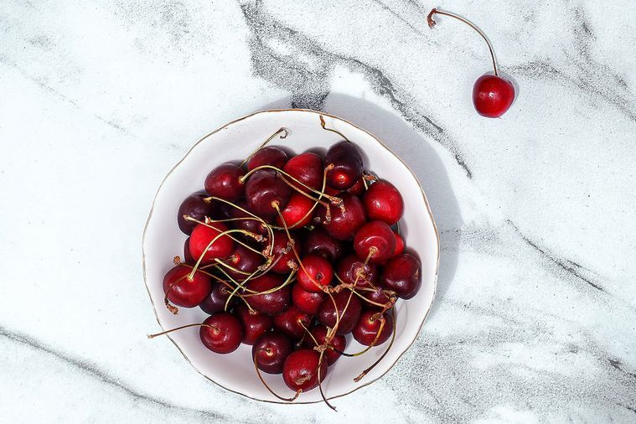

[](https://www.delicious.com.au/people-events/people/alison-turner/swv4bn4a)

##### [BY ALISON TURNER](https://www.delicious.com.au/people-events/people/alison-turner/swv4bn4a)

##### [DELICIOUS. CHIEF SUB EDITOR](https://www.delicious.com.au/people-events/people/alison-turner/swv4bn4a)

##### NOV 04, 2022

**It’s the pits.**

Cherries are as synonymous with Christmas as mangoes are with summer. But this year, they may be harder to come by. And as you’ve probably already guessed, old mate [La Niña](https://www.delicious.com.au/food-files/news-articles/article/milk-prices-set-rise-farmers-battle-floods-cost-increases/cst3uu3g) is to blame.

That’s right – the relentlessly soggy weather wasn’t satisfied with just ruining all your social plans and turning your hair to frizz. Now it’s casting its gloomy cloud over the Christmas cherry supply.

According to food and agribusiness financial services cooperative Rabobank, while the cherry sector is in an “expansion phase”, the third consecutive [La Niña](https://www.delicious.com.au/food-files/news-articles/article/sunrice-says-la-nina-could-cause-rice-shortage-australia/3uhk0upw) currently underway in Australia increases the likelihood of a wet harvest, which could cause splitting in this year’s cherry crop. This will mean [reduced local supply](https://www.delicious.com.au/food-files/news-articles/article/potato-chip-shortage-set-hit-australian-supermarkets/j958gofc), which also means higher prices.

If you do manage to score yourself some choice cherries this coming season, don’t just use them as bespoke earrings – make the most of them in [these easy recipes](https://www.delicious.com.au/recipes/collections/gallery/make-the-most-of-cherry-season-with-these-28-recipes/sfkicw9k).

# Why so many restaurants are hooked on Australian barramundi

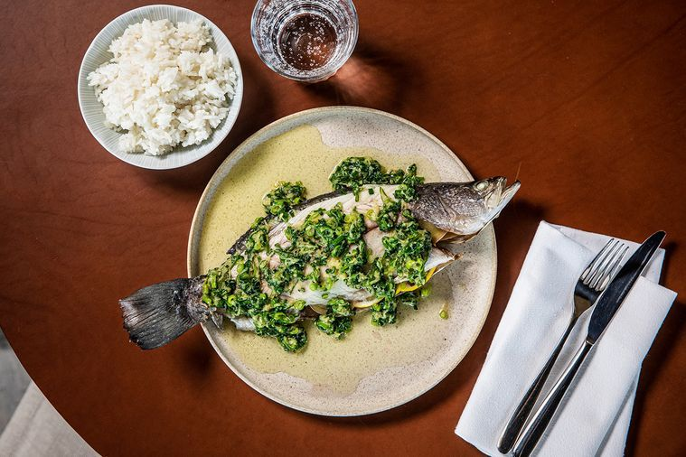

[](https://www.delicious.com.au/people-events/people/george-epaminondas/fz0u3ijb)

##### [BY GEORGE EPAMINONDAS](https://www.delicious.com.au/people-events/people/george-epaminondas/fz0u3ijb)

##### OCT 14, 2022

**There’s something fishy about barramundi when so much of it comes from overseas.**

Is there anything more Australian than barramundi? The succulent, sustainable fish is up there with meat pies, lamingtons and [Vegemite](https://www.delicious.com.au/recipes/collections/gallery/8-ways-to-cook-with-vegemite-this-australia-day/24aq5vus) as an integral part of our culinary heritage. But unlike those other homegrown foods, much of the barra we consume hails from abroad.

According to The Australian Barramundi Farmer’s Association, a network of producers from Humpty Doo to the Coral Coast, almost 60 percent of the fish is imported into Australia. To address this imbalance, the association is sponsoring National Barramundi Day this Friday.

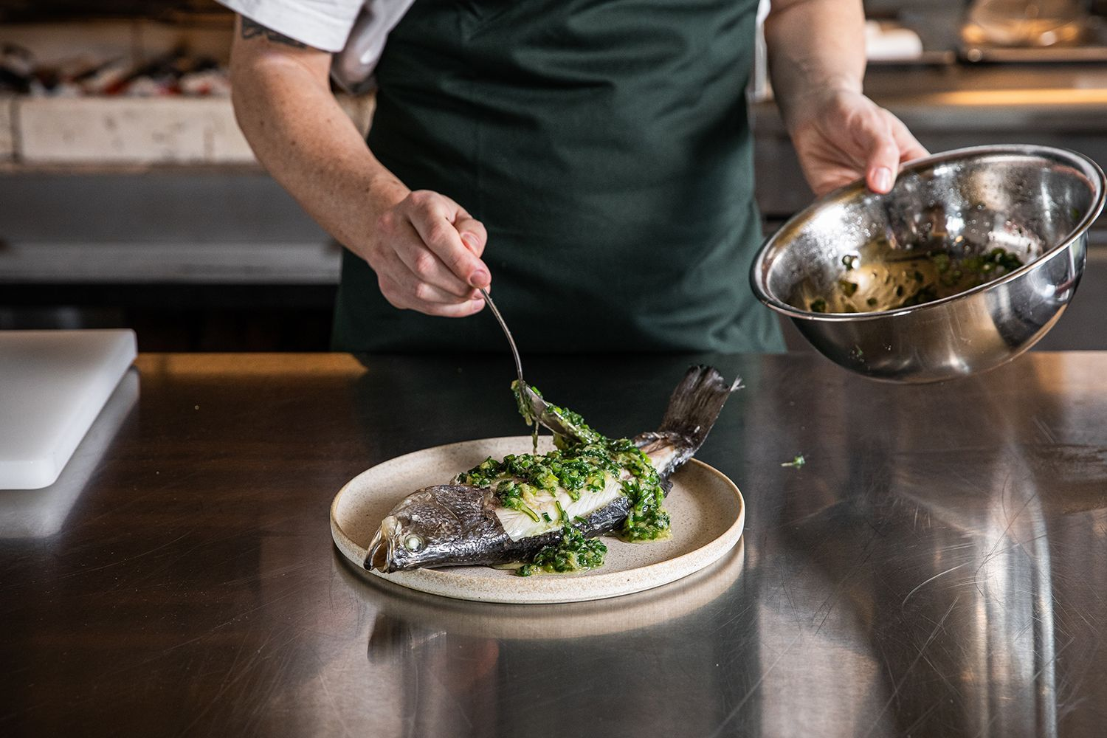

Over 100 restaurants across the country, including Sydney’s Catalina, Melbourne’s Grossi Florentino and Perth’s Cooee, will be offering specialty dishes that showcase farmed Aussie barra – the fact the fish has its own beloved diminutive confirms its revered place.

***Related story:***[***Catch a break with these 12 easy barramundi recipes***](https://www.delicious.com.au/recipes/collections/gallery/barramundi-fish-recipes-baked-roasted-fried/yb30ew12)

Additionally, the association has reeled in star chef Mitch Orr, from just-opened Kiln restaurant atop Sydney’s Ace Hotel, to inspire home cooks with three recipes that showcase its versatility: steamed barramundi with [ginger](https://www.delicious.com.au/recipes/group/gallery/sweet-desserts-kick-ginger/my7hw0wp) and scallions; grilled barramundi with desert lime and pepper; and fried barramundi with Old Bay seasoning and green tomatoes.

“Everyone has a barra story, whether it’s catching ‘the fighter fish’ yourself or cooking it up and sharing it on the Christmas barbecue,” says Orr. “It’s got a unique place in the history of Australian cuisine.”

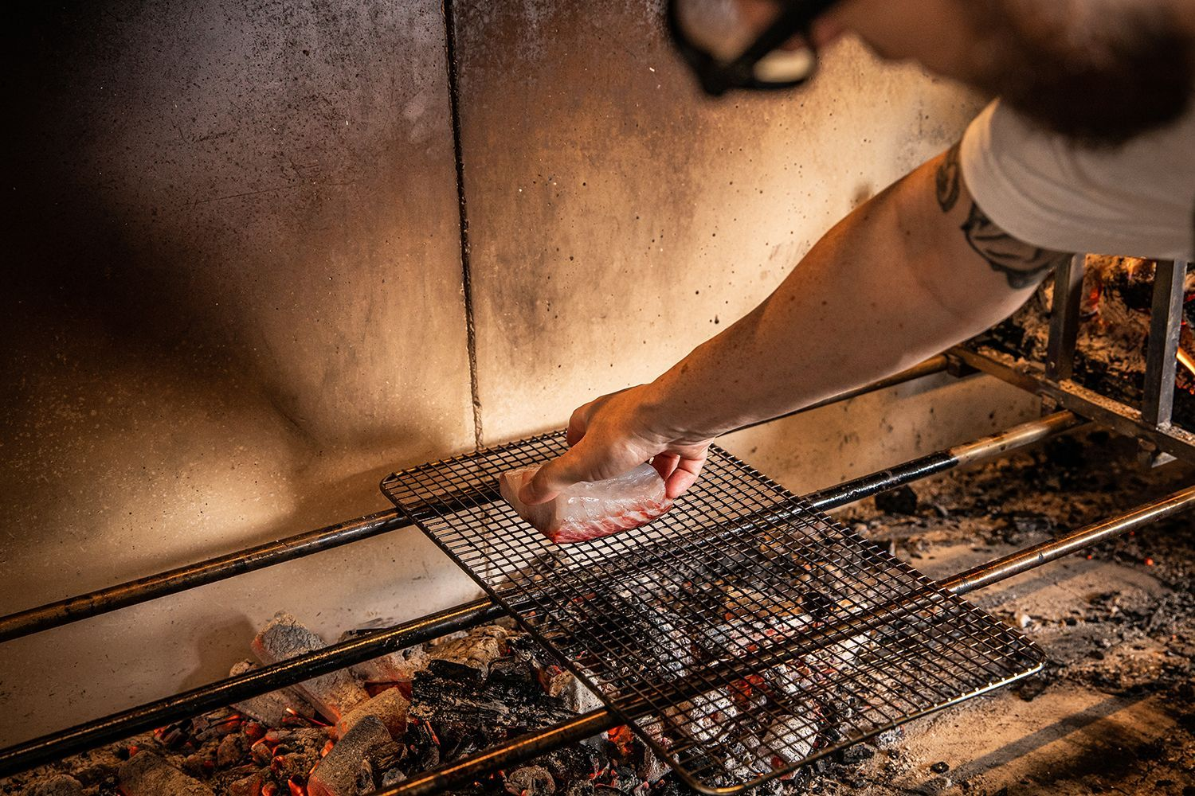

Though national legislation is pending that would require vendors and restaurants to indicate where their seafood originated, consumers still need to question the provenance of their [fish](https://www.delicious.com.au/recipes/collections/gallery/42-fish-recipes-to-make-this-spring/en7nwq4x). “When you go to your local restaurant, shop or fishmonger, just ask them directly where they get their fish from so you can make an informed choice,” adds Orr.

1. **Everything You Avo Wanted**

* Khi click vào hình

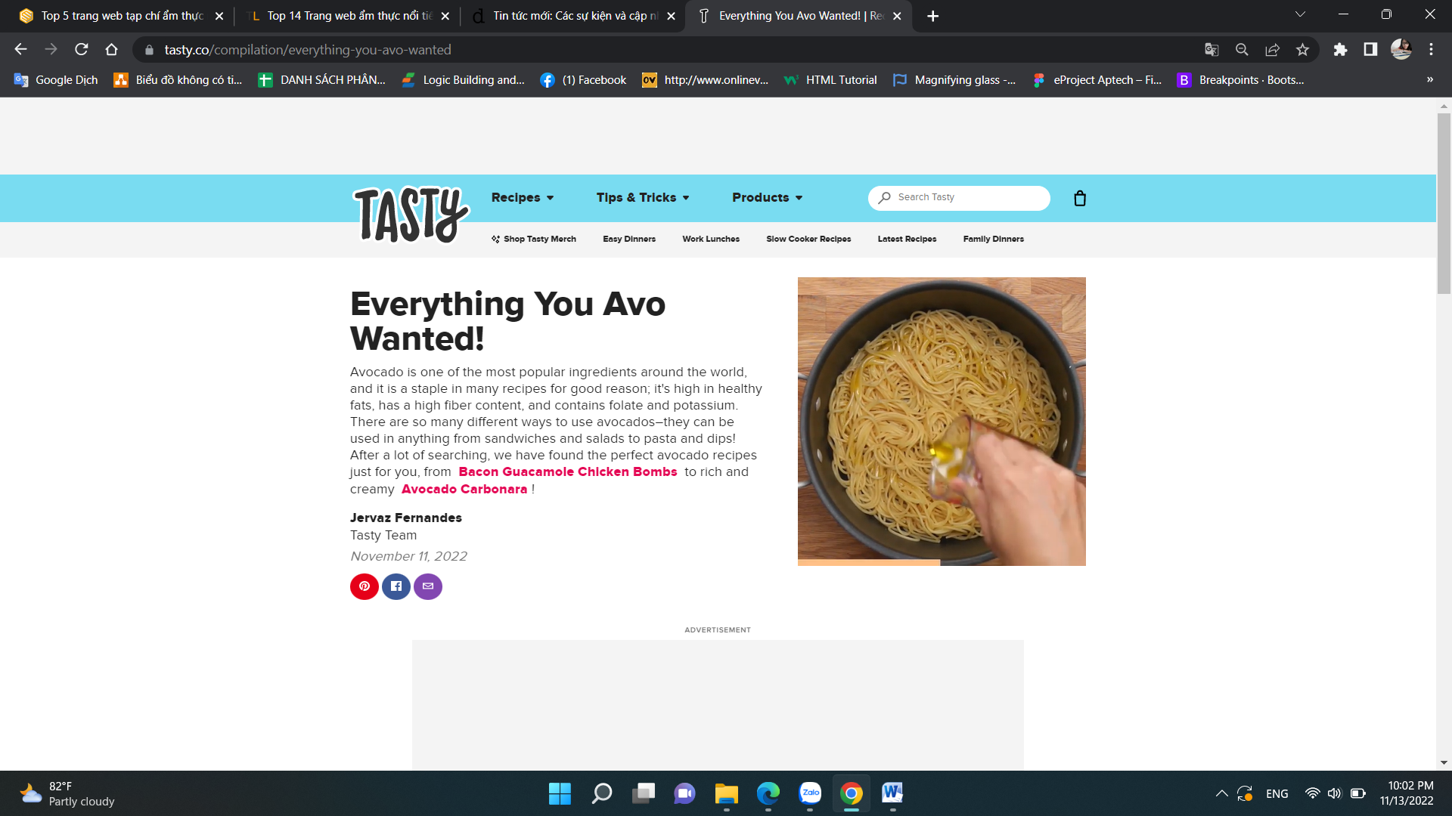

**Everything You Avo Wanted!**

Avocado is one of the most popular ingredients around the world, and it is a staple in many recipes for good reason; it's high in healthy fats, has a high fiber content, and contains folate and potassium. There are so many different ways to use avocados–they can be used in anything from sandwiches and salads

**Video**

to pasta and dips! After a lot of searching, we have found the perfect avocado recipes just for you, from Bacon Guacamole Chicken Bombs to rich and creamy Avocado Carbonara !

Jervaz Fernandes

Tasty Team

November 11, 2022

* Khi nhấp vào Bacon Guacamole Chicken Bombs



**Ingredients**

for 8 chicken bombs

* 2 ripe avocados
* ½ white onion, finely chopped
* ½ tomato, chopped
* 2 tablespoons chopped fresh cilantro
* ½ tablespoon kosher salt, plus more to taste
* 2 tablespoons fresh lime juice

4 boneless, skinless chicken breasts

* black pepper, to taste
* 8 strips bacon
* 1 tablespoon canola oi

**Preparation**

1. Preheat the oven to 400°F (200°C).
2. Using a knife, cut around the pit of each avocado, separating the halves from each other. Remove the pits and use a spoon to scoop out the flesh.
3. In a large bowl, combine the avocado, onion, tomato, cilantro, salt, and lime juice. Mash and stir with a fork until there are no large chunks of avocado left.
4. Season the chicken breasts with salt and pepper on all sides. Slice chicken breasts in half crosswise.
5. Cut a slit in the center of each half to make a pocket. Take a heaping spoonful of the guacamole and pack it into the pocket. Pinch the edges closed.
6. Wrap each chicken breast with 2 strips of bacon, making sure the ends of the bacon all end up on the same side of the chicken.
7. Heat oil in a large pan over high heat. Sear the bacon-wrapped chicken for 2-3 minutes on each side. Remember to sear the sides of the chicken as well.
8. Transfer the chicken to a baking dish and bake for 10 minutes, or until cooked through and the internal temperature reaches 165°F (75°C). Serve immediately.
9. Enjoy!

Video

* Khi nhấp vào Avocado Carbonara



**Ingredients**

for 2 servings

* 1 avocado
* 1 egg yolk
* ½ cup heavy cream(120 mL)
* 1 clove garlic
* ½ lemon, juiced
* ½ cup parmesan cheese(55 g), grated
* 3 strips bacon
* ½ lb spaghetti(225 g)
* 1 tablespoon olive oil

**Preparation**

1. Blend avocado, egg yolk, garlic, and lemon juice in a powerful blender or food processor.
2. Pulse to blend and add heavy cream gradually. Blend the sauce until smooth and set aside.
3. Cut up strips of bacon and cook in a large pan. Set aside.
4. In a large pot, bring water to a boil and cook the spaghetti according to the package instructions.
5. Drain and coat with olive oil.
6. Add sauce, bacon, parmesan, salt and pepper, stirring until well-combined.
7. Serve and sprinkle with parmesan.
8. Enjoy!

Video

## [Food are increasing across the world, and ramen could be next](https://www.delicious.com.au/food-files/news-articles/article/covid-adverse-weather-have-impacted-global-food-supply-chains/dmcq3c1b)





##### [NEWS + ARTICLES](https://www.delicious.com.au/food-files/news-articles)

## [Food shortages are increasing across the world, and ramen could be next](https://www.delicious.com.au/food-files/news-articles/article/covid-adverse-weather-have-impacted-global-food-supply-chains/dmcq3c1b)

**BY**[**SABINE LEROY**](https://www.delicious.com.au/people-events/people/sabine-leroy/h16zq2po)

* Khi nhấp vào hình or chữ



**From cars, computer chips and lumber to KFC chicken, garage doors and even toilet paper, Covid created havoc and impacted global supply chains in almost every industry.**

Though the pandemic has somewhat settled, certain foods around the world are now facing regional, if not global shortages.

## ****Ramen noodles****

Reuters reports that Japan’s low-cost soul food noodles is likely to become the latest casualty of the conflict in Ukraine. Traditionally eaten on New Year’s Eve for good luck – and every other day – [noodles](https://www.delicious.com.au/recipes/collections/gallery/best-noodle-recipes/psj6my0f) are made of buckwheat, and who produces a lot of buckwheat? Russia. While Japan produces its own, the country imports the lion’s share of buckwheat from abroad.



Russian buckwheat can still be imported, but instability and shipping disruptions are making its procurement unstable. Combined with the rising cost of living, rising commodity prices and the yen’s plunge, soba noodle makers and Ramen masters have no choice but to increase their prices. The once ultra cheap meal has almost doubled in price in some restaurants.

## ****Stock up on Sriracha****

The much-loved spicy condiment has also become scarce. The Huy Fong company that makes the hot sauce announced in June that chilli peppers continue to be in very short supply due to droughts in [Mexico](https://www.delicious.com.au/recipes/collections/gallery/40-mexican-recipes-for-your-weekend-fiesta/6k3n6ehf) and other chilli-growing regions.

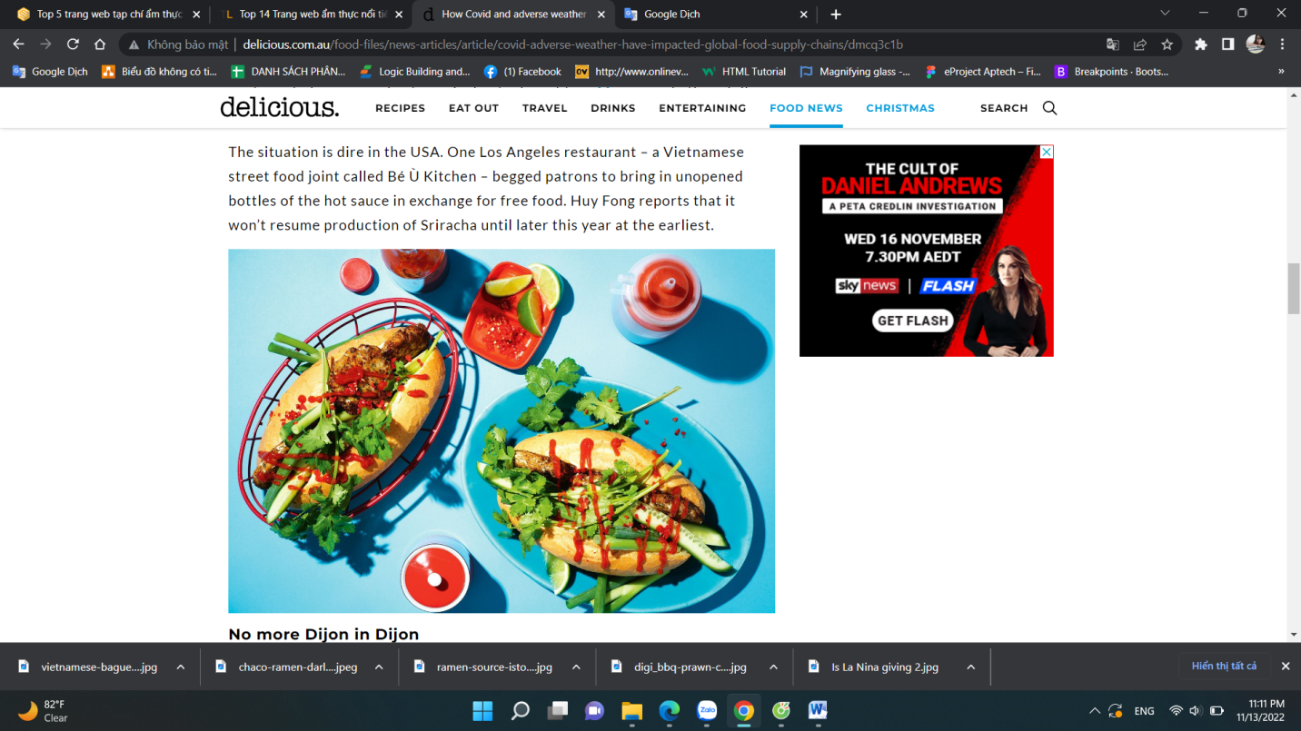The situation is dire in the USA. One Los Angeles restaurant – a Vietnamese street food joint called Bé Ù Kitchen – begged patrons to bring in unopened bottles of the hot sauce in exchange for free food. Huy Fong reports that it won’t resume production of Sriracha until later this year at the earliest

## ****No more Dijon in Dijon****

Don’t expect Dijon if you order steak in Paris. In France, mustard shelves are empty as the country faces Dijon mustard shortage. A staple in every French home, supermarkets have started rationing mustard purchases when deliveries arrive. Shoppers are allowed to buy just one pot per person.

Originating from the town of Dijon in Burgundy, the mustard dates back to 1634 and was created by combining brown mustard seeds with white wine. The seeds were co-planted with the region’s renowned grapevines, a practice introduced by the Ancient Romans to provide the vines with essential nutrients. But the use of French seeds to produce the condiment has been delocalised for quite some time. Dijon is now made with Canadian mustard seeds, with the country producing 80 per cent of the world’s supply. Unseasonal weather obliterated the Canadian crop, sending seed prices skyrocketing.

## ****Dud spuds****

Chips, mash, gnocchi, vodka or dumplings, there’s so much to love the [potato](https://www.delicious.com.au/recipes/collections/gallery/100-recipes-that-prove-potatoes-arent-bad-for-you/fmhucdsg) for. Farmers around the world are struggling to grow potatoes due to mother nature, and Australia is no exception. Due to the cold climate and frost in some parts of the country, potatoes are not growing the way they’re meant to, meaning only 50 per cent of potatoes produced are fit for sale.

It’s seen global fast food chains like McDonald’s and KFC face fries shortages. Late last year, McDonald’s in Japan temporarily limited sales of medium and large French fries to manage the shortage. KFC in Kenya ran out of fries completely in January and instead offered customers alternatives such as a portion of the national staple, ugali, or maize meal.

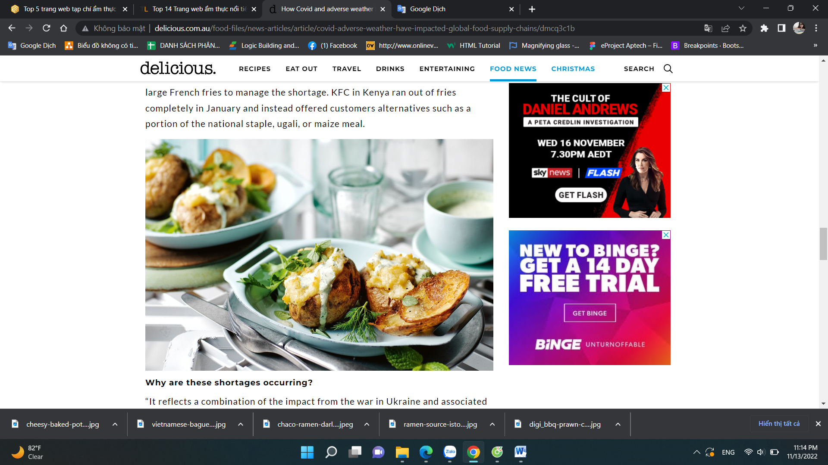

### ****Why are these shortages occurring?****

“It reflects a combination of the impact from the war in Ukraine and associated sanctions – which has impacted grains along with fertiliser, adverse weather conditions (e.g. drought in parts of the US and Europe and of course flooding in parts of Australia affecting fruit and vegetables) and residual production disruptions associated with the pandemic,” explains Shane Olliver, Chief Economist at AMP Capital.

“It will ease in time – but much depends on the weather and war in Europe.”

This article originally appeared on [*escape.com.au*](https://www.escape.com.au/travel-advice/why-a-bowl-of-ramen-is-about-to-get-more-expensive/news-story/abb6ccb111672381f058b559e815b999). It has been reproduced here with permission.

# Science says



##### [HEALTH](https://www.delicious.com.au/food-files/health)

## [Science says consuming wine and cheese daily is good for your brain](https://www.delicious.com.au/food-files/health/article/science-says-consuming-wine-cheese-daily-good-brain/aouvjs9s)

**BY**[**ROSEMARY SLADE**](https://www.delicious.com.au/people-events/people/rosemary-slade/c8lky6yh)

* Khi nhấp vào hình ảnh or chữ



**Cab sav and camembert all around, then?**

It’s gouda news for cheese fiends and vino aficionados: a new study shows that consuming more [wine](https://www.delicious.com.au/food-files/health/article/drinking-red-wine-may-lower-blood-pressure-new-research-shows/uhw51czx) and cheese may help to protect against age-related cognitive decline.

The research findings by Iowa State University, which was published as part of a larger study in the Journal of Alzheimer’s Disease, found that individuals who consumed specific foods regularly were more likely to show mental acuity later in life.

Researchers analysed data collected from 1,787 adults between the ages of 46 and 77 to find out which dietary modifications could be linked to the prevention of age-related cognitive decline.

Participants completed a Fluid Intelligence Test (FIT), which provides an in-time snapshot of an individual’s ability to “think on the fly.” Participants then answered questions about their intake of specific foods, including fresh fruit, dried fruit, raw vegetables and salad, cooked vegetables, oily fish, lean fish, processed meat, poultry, beef, lamb, pork, cheese, bread, cereal, tea and coffee, beer and cider, red wine, white wine, champagne and liquor.

The study yielded four significant findings. Researchers concluded that cheese was, by far, the most protective food against age-related cognitive problems, even late into life. They also found daily consumption of alcohol – specifically red wine – was related to improvements in cognitive function.

Interestingly enough, weekly consumption of lamb (but not other red meats) was also shown to improve long-term cognitive prowess.

The study also concluded that excess salt consumption was associated with cognitive problems, but that only individuals already at risk for Alzheimer’s Disease needed to watch their intake.

Needless to say, with cognitive health as the focus of the study, the research should be taken with *ahem* a grain of salt, since plenty of other studies have shown that excessive salt intake can affect other aspects of your health.

“I was pleasantly surprised that our results suggest that responsibly eating cheese and drinking red wine daily are not just good for helping us cope with our current COVID-19 pandemic, but perhaps also dealing with an increasingly complex world that never seems to slow down,” said principal investigator, Auriel Willette.

“While we took into account whether this was just due to what well-off people eat and drink, randomised clinical trials are needed to determine if making easy changes in our diet could help our brains in significant ways.”

# Christmas countdown calendar: what to do at 2 weeks



##### [NEWS + ARTICLES](https://www.delicious.com.au/food-files/news-articles)

## [Christmas countdown calendar: what to do at 2 weeks](https://www.delicious.com.au/food-files/news-articles/article/christmas-countdown-calendar-2-weeks/inA5J7mv)

**BY**[**DELICIOUS. TEAM**](https://www.delicious.com.au/people-events/people/delicious-team/jm9n0yzl)

Nội dung:



## ****Bake or feed your Christmas cake or pudding****

Going for a traditional Christmas cake or pudding this year? If you haven’t already, it’s time to throw on your apron and mitts. The longer the flavours have to deepen, the richer your pud will be. If you’ve already baked your pud, give it a little top up of booze (brandy or rum are always a winner) to really get all those fruits dancing. It’s a good idea to make a few extras to cloth-wrap and gift later – nothing goes down better than a house-baked festive treat. Packed full of fruits and nuts, these [individual Christmas puddings](http://www.delicious.com.au/recipes/individual-christmas-puddings/e1d98323-9576-4ae7-97c5-d36bc8cbccdc?current_section=recipes&adkit_ref=/recipes/collections/christmas-baking-ultimate-collection/71479438-09ce-44c1-9031-2885aa349d53) will reaffirm your domestic god(dess) status, as will Maggie Beer’s traditional [Christmas pudding with brandy butter](http://www.delicious.com.au/recipes/christmas-pudding-brandy-butter/0f0ca9c8-c3e7-4b25-8e72-d750c62e446d?current_section=recipes&adkit_ref=/recipes/collections/christmas-baking-ultimate-collection/71479438-09ce-44c1-9031-2885aa349d53).

## ****Finalise your bar list****

Nothing dials up the festive spirit like a little Christmas tipple – and maybe a little Bublé, too. Pen your final list and make sure you have all the tools you need for your party pantry (punch bowls, muddlers, martini glasses, etc). Stay dangerously on trend with the summer’s hottest (chilled) drink – [the frosé](http://www.delicious.com.au/recipes/frose-frozen-rose-perfect-summer-treat/32523ab5-8348-479b-88a9-7080ba751d9b?current_section=recipes) (that’s a frozen rosé berry cocktail for those playing at home). Or kick it up a notch in the fancy stakes with this sparkling [gold leaf cocktail](http://www.delicious.com.au/recipes/24-carat-christmas/919824ae-918c-4f97-9059-cce1d4e1d939?current_section=recipes) and have yourself a 24-carat Christmas. A punch is a great way to feed a crowd – this [Pimm’s version](http://www.delicious.com.au/recipes/pimms-punch/06daf9f7-dba8-40e4-93cd-05e341ed21f6?current_section=recipes) is always a crowd-pleaser, as are these [grapefruit and ginger virgin zingers](http://www.delicious.com.au/recipes/grapefruit-ginger-virgin-zingers/96o5T4aD?current_section=recipes).

## ****Every good drinks list has a killer snack menu****

We’re not saying sideline the Jatz (gasp) but, rather, unleash the star power of your crackers/lavosh/baguette with some homemade dips. Up the flavour and texture stakes with this [beetroot and orange dip with rose and pistachios](http://www.delicious.com.au/recipes/frose-frozen-rose-perfect-summer-treat/32523ab5-8348-479b-88a9-7080ba751d9b?current_section=recipes), or this speedy, savoury [broad bean and feta dip.](http://www.delicious.com.au/recipes/broad-bean-feta-dip/0kdKudJ5?current_section=recipes) Nan won’t be the only one smiling if you give this [new and improved cob dip](http://www.delicious.com.au/recipes/barramundi-cob-dip/muGCeir5?current_section=recipes) a spin – it features barramundi for a quintessentially Aussie makeover. Buy all the dry bits now – there’s no reason your pantry can’t be overflowing with all that dipping arsenal.

## ****Opt out of a Christmas cook-up****

Sound controversial? Imagine not having to turn on a single dial or flame all day. We’re talking a cold Christmas spread to rival any hot feast; think [spicy prawn cocktails](http://www.delicious.com.au/recipes/spicy-prawn-cocktails/3611a0fa-4910-4a8b-8a96-9eb93c612b5c?current_section=recipes), [lobster rolls](http://www.delicious.com.au/recipes/valli-littles-lobster-rolls/38a26622-606f-4f5b-bda2-1d6fbd58a1ee?current_section=recipes), [walnut paté](http://www.delicious.com.au/recipes/walnut-pate-august/b14f3a6b-e15b-4701-936a-c2f9d6098275?current_section=recipes), [beetroot-cured gravalax](http://www.delicious.com.au/recipes/beetroot-gravlax-goats-curd/2d368adf-f6c1-4dd7-aec7-e8dcb4c4c1ff?current_section=recipes) and [ceviche](http://www.delicious.com.au/recipes/ceviche/79932952-81b9-4716-81d0-1443e99ff4eb?current_section=recipes). For added wow-factor, add your own pre-prepared [oyster bar](http://www.delicious.com.au/recipes/oyster-bar/f19e58fb-1540-4c4e-b7e7-482c35504624?current_section=recipes) to the fold. And come dessert, no one will say no to a slice of this [no-bake blueberry cheesecake](http://www.delicious.com.au/recipes/no-bake-blueberry-cheesecake/2e2e43ab-e29a-4d18-8d09-a6cd2859f795?current_section=recipes&adkit_ref=/recipes/collections/no-bake-dessert-recipes/ec8dfb63-167e-4a00-b428-591ae97d2cf3). No burn scars, stove-induced heat stroke or burnt pie crust in sight. Finalise your shopping list and buy as much as you possibly can now, leaving the fresh stuff until a bit later.

## ****Ham it up – or don’t, your call****

Have you placed your ham order with your supermarket deli or butcher yet? While you’re at it, stock up on everything else you need to create that show-stopping masterpiece: think spices, marmalade and ham bag. And ginger beer, if you’re opting for delicious. columnist [Colin Fassnidge’s Christmas ginger beer-glazed ham](http://www.delicious.com.au/recipes/colin-fassnidges-christmas-ginger-beer-glazed-ham/71038d44-e6ca-4d2f-aa63-0814fe6f258e?current_section=recipes&adkit_ref=/recipes/collections/christmas-ham-recipes-complete-collection/a8509842-83a6-499c-a850-6c7442ec39cf). Or is this the year lamb wins? Whether you’re going for cutlets, a whole leg or slow-cooked – we’ve got you sorted.

See our ultimate [Christmas lamb recipes](http://www.delicious.com.au/recipes/collections/gallery/64-lamb-recipes-make-christmas/YNr8FZFy).

## ****Choose your pavlova****

You’ll notice how we just skipped to the part where you’ve already decided you’re making a pav. The straight-up summer fruits and cream will never disappoint, but why not try a new riff on the Aussie summer classic? We love this Woolworth’s [tropical](http://www.delicious.com.au/recipes/tropical-pavlova/48906905-d761-4b9d-ab19-a547c0675e24?current_section=recipes) pav with coconut cream and shards of almond toffee or take it right back to the Persian Empire with this [rosewater, pistachio and pomegranate version](http://www.delicious.com.au/recipes/persian-pavlova/d4b6dd95-1945-43f4-a500-0d0ebd6ab52b?current_section=recipes). Or for a chocolatey, fruity, shut-the-chimney-now version, make it this [black forest pavlova.](http://www.delicious.com.au/recipes/black-forest-pavlova/VIEmzd2A?current_section=recipes)

### WHAT IS FETA / SIRENE (Bulgarian Cheese)?

**Feta**

[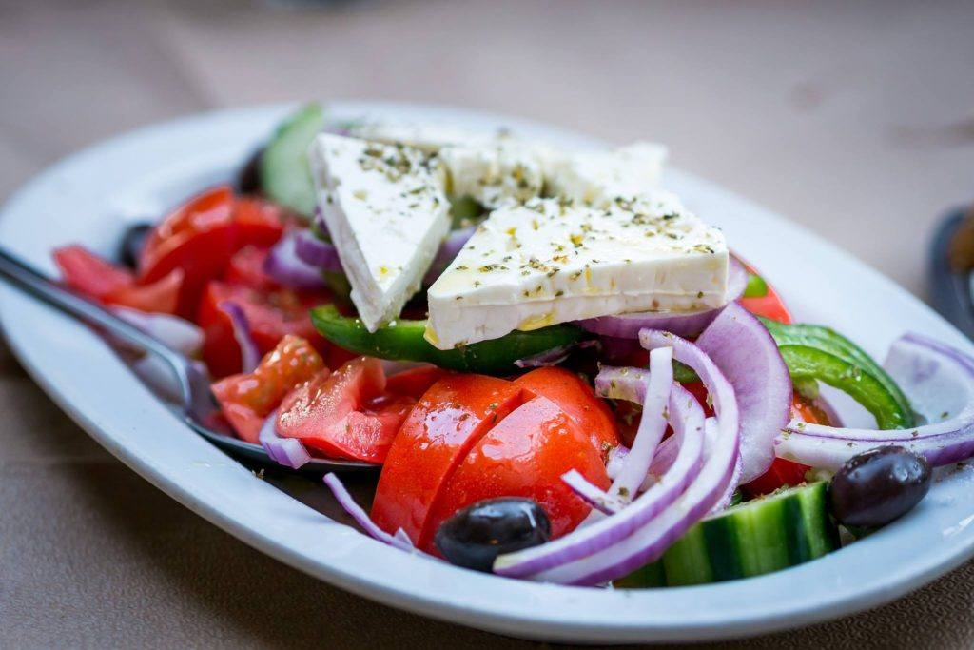](https://133777-1202060-raikfcquaxqncofqfm.stackpathdns.com/wp-content/uploads/2019/04/Feta-Greek-salad-2430919_1920.jpg)

Most listeners will have tried feta already. its a brined curd white cheese made from sheep’s milk or from a mixture of sheep and goat’s milk. It is a crumbly aged cheese, normally at least 3 months aged, commonly produced in blocks, and has a slightly grainy texture with a salty hit.

The October 2002 European Union bill limits the term feta to mean a brined cheese mad only from sheep’s milk or a mix of sheep and goat’s milk, with a max 30% of goat’s milk. Feta must be made in certain regions of Greece, specifically: Peloponnese, Epirus, Thessaly, Central Greece, Macedonia, Thrace, plus the islands of Lesvos and Cephalonia.

The biodiversity of the land coupled with the special breeds of sheep and goats used for milk is what gives feta cheese a specific aroma and flavor. Which is one of many reasons we’ll discuss why The name feta has become a protected origin product.

It should be noted that, at time of recording, the USA has not accepted this protected status and feta cheese purchased in the USA may not have been produced in Greece. Though talks are underway on a massive trade deal between the EU and USA that would potentially change this.

#### ****Sirene (Bulgarian Cheese)****

[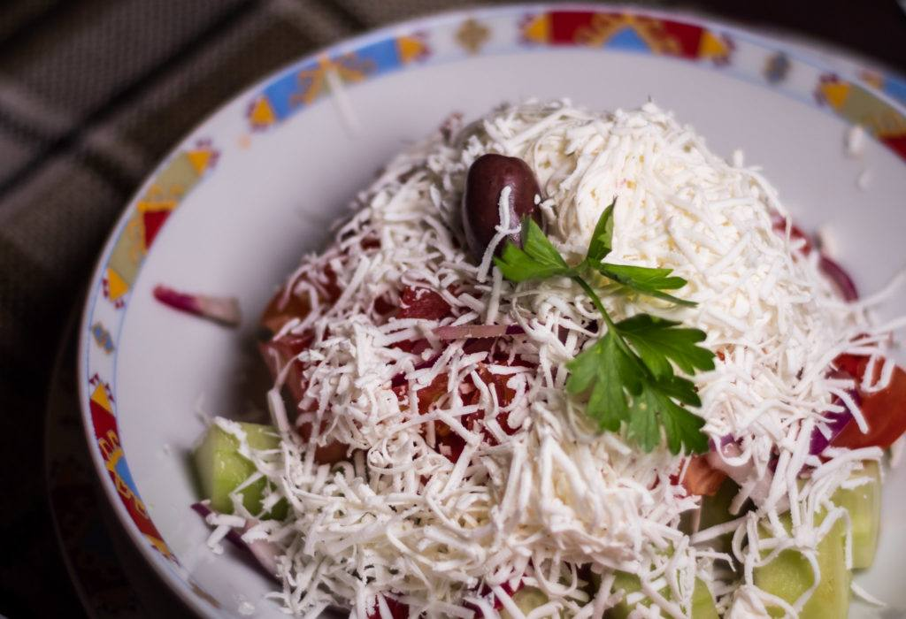](https://133777-1202060-raikfcquaxqncofqfm.stackpathdns.com/wp-content/uploads/2019/03/Shopska-Salad.jpg)

Bulgarian Cheese on The Shopska Salad

Sirene Bulgarian Cheese can be made from a combination of goat, cow and sheep milk. There is no regulation on which, or the proportions. It’s is a little softer and wetter than feta cheese, but still crumbly and has a fat content of around 44-48%. It has a grain texture and slightly lemony flavor. I find it just a little creamier than feta, normally.

Bulgarian cheese is used for so many culinary applications, from salads to baked goods (like the Banitsa pastry), also in dips or added to other dishes. It may also be served as a table cheese.

#### ****Other White Cheese****

[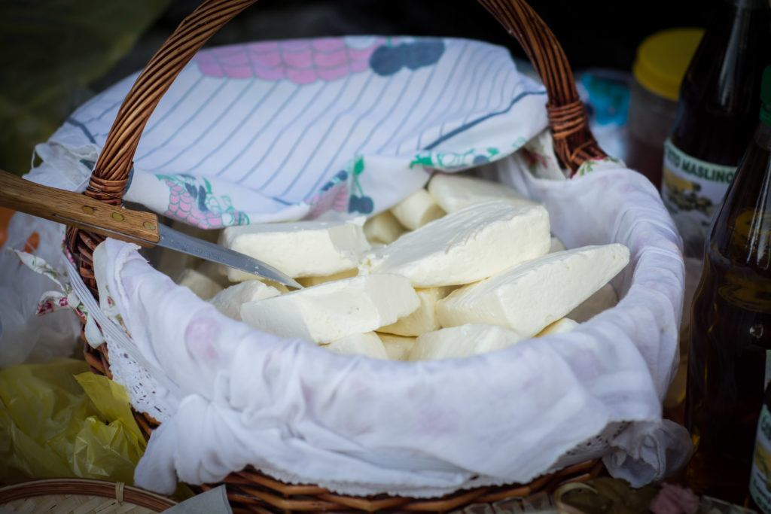](https://133777-1202060-raikfcquaxqncofqfm.stackpathdns.com/wp-content/uploads/2019/04/White-Cheese-Montenegro.jpg)

White Cheese In Montenegro

In Romania, the equivalent cheese is called “Telmea”

Each brined white cheese from the Balkans and middle east are distinctly different but are made in a very similar way. The proportion and type of milk, the breed of animal the milk comes from, as well as the climate affect the final product.

In Lebanon, as well as having imported Greek Feta cheese, they also have Bulghari – which is a separate product that mimics the free use of milk that Sirene does – mixing in cow’s milk as well. So it’s also important to remember that our narrow English culture view of cheese history is not the only way of looking at this. Other cultures are very aware of the difference between white cheeses across the region.

It’s fair to say these cheeses all taste different, though similar. It’s like comparing Grana Padano to Parmigiano Reggiano cheese – similar style, but different taste. I can say with certainty that the “Salad Cheese” we get at our current local supermarket in portugal is absolutely inferior to the certified Feta from the same store. Of course, differences can also be down to production style and quality, so our personal test is just that – not of any scientific rigour

I have to say I loved almost all the good quality Bulgarian Sirene cheese. And Good feta is great too. It’s hard to say one is better than the other when it depends on individual batches and production.

## History of Feta Cheese & White Cheese In General

Though food historians don’t know the exact origin of white cheese, it’s believed that cheese making existed since at least 8000 BC and could have started very close to original domestication of livestock – so possibly even as far back as 10,000 BC.

The oldest reference to White brined cheese is said to be from famous greek writer Homer’s Oddyssey, from 800BC. And I quote:

“We entered the cave, but he wasn’t there, only his plump sheep grazed in the meadow. The woven baskets were full of cheese, the folds were full of sheep and goats and all his pots, tubs and churns where he drew the milk, were full of whey. When half of the snow-white milk curdled he collected it, put it in the woven baskets, and kept the other half in a tub to drink,” Homer wrote.

Homer’s fiction suggests The Cyclops Polyphemus knew how to make Feta cheese – though it wasn’t called that at the time. The fictional description shows that Homer, and hence the people of Greece in general, were very familiar with the cheese making process and specifically white cheeses.

The ancient Greeks called the product which came from the coagulation of milk “τυρí,” (Tyri).

The name Feta translates as “slice” and began being used to describe the white cheese from the 17th century onwards, probably because of the way the cheese was sliced in barrels.

However, the word *fetta* – with two t’s – is the Italian word for slice, and etymologists confirm the word derives from the Italian and Latin before that, not from Greek.

The name Feta prevailed in the 19th century as the main term for the cheese in Greece.

Mass immigration from Greece in the 20th century to countries like Australia, USA, Canada and Germany helped spread Feta cheese and its production around the world and boosted its international profile.

At the same time, other cultures from around the region continued to make their own white cheese to their only local preferences, as they had done for thousands of years. Most have their own local names, but Feta became the generic term, especially in English, that was used to understand this general type of cheese as well as versions of it that were by the mid 20th century being made all over the world.

From Denmark, to the UK and USA, types of feta were being produced and marketed under that name. In Denmark specifically, their Feta was focused on Cows milk, quite different from the Sheep and goat milk feta of Greece.

In the 1990’s, Greece petitioned the EU to protect the origin of Feta by giving them a geographic designation and banning other cheesemakers from marketing under the name Feta. This bill was passed in 2002.

* 1. Celebrating With Sauvignon – Why It’s So Popular

**A Food Fun Travel Guest Post**

Sauvignon blanc is a white wine grape that originates from the Bordeaux region of France. The grape is known for its high acidity and distinctive aromas, which can include notes of grass, grapefruit, and passionfruit. [Sauvignon blanc](https://wine.qantas.com/c/white-wine/sauvignon-blanc) is used to make both dry and sweet wines, although it is most commonly associated with dry white wines.

The grape is planted in many different regions around the world, and the resulting wines can vary significantly in style. In general, Sauvignon blanc wines are best enjoyed young, although some producers do make aged versions that can develop complex flavours with time. Whether you’re a fan of dry or sweet white wines, chances are you’ve tried a Sauvignon blanc at some point.

Sauvignon blanc is a highly versatile wine that can be enjoyed both on its own and with food. Here are six reasons why it has become so popular:

## Sauvignon Blanc Has a Refreshing, Zesty Flavour That Makes It Perfect for Summer Drinking

Sauvignon blanc wines are usually light-bodied with high acidity. They often have flavours of citrus, green apple, and herbal notes. The best Sauvignon blancs have a balance of acidity and fruitiness, with a long mineral finish. When shopping for Sauvignon blanc, look for wines from cooler climates such as New Zealand or Chile.

These wines will have higher acidity and brighter fruit flavours. If you’re looking for a richer style of Sauvignon blanc, look for wines from warmer climates such as California or Australia. These wines will have [softer acidity](https://businessdesk.co.nz/article/the-life/acid-test-why-we-should-be-savouring-sauvignon-blanc) and more round, ripe fruit flavours. No matter what style you choose, make sure to serve your Sauvignon blanc chilled – it’s the perfect summer wine.

## 2. It is Relatively Low in Alcohol, So It is a Good Choice for People Who Want to Avoid Getting Too Drunk

This type of wine [has an alcohol content of around 12 per cent](https://www.realsimple.com/holidays-entertaining/entertaining/food-drink/alcohol-content-wine), which is lower than many other types of wine. As a result, it is a good choice for people who want to avoid getting too drunk. In addition, sauvignon blanc is a refreshing and fruity wine, making it a great choice for summertime drinking. So if you’re looking for a light and refreshing wine, then sauvignon blanc is a good option.

## 3. Sauvignon Blanc is a Great Match for Food, Especially Seafood and Salads

Sauvignon blanc is one of the most versatile white wines when it comes to food pairing. Its high acidity and zesty citrus flavours make it a great match for lighter fare like seafood and salads. But it’s also delicate enough to pair with more delicate flavours like chicken and tofu.

And because it’s not a very fruity wine, it’s also great for dishes with cream sauces or richer cheeses. So whether you are serving up fresh fish or a hearty pasta dish, Sauvignon blanc is always a good choice.

## 4. It is Relatively Inexpensive, So It is a Good Choice for Budget-minded Wine Drinkers

At first blush, Sauvignon blanc may not seem like a bargain wine. After all, it is often found on the wine lists of upscale restaurants, and it has garnered its fair share of awards over the years. However, compared to other premium white wines, Sauvignon blanc is relatively inexpensive.

This makes it a great choice for budget-minded wine drinkers who are looking for a high-quality bottle of wine. In addition, Sauvignon blanc is extremely versatile, pairs well with a wide range of foods, and is perfect for any occasion.

## 5. Sauvignon Blanc is Easy to Find, as It is Produced by Many Different Wineries Around the World

Sauvignon blanc is a versatile white wine that pairs well with a variety of foods. It is also easy to find, as it is produced by many different wineries around the world. The grape originated in France, and the name [sauvignon blanc comes from the French word for “wild.”](https://www.winetourism.com/sauvignon-blanc/#:~:text=The%20name%20Sauvignon%20Blanc%20comes,ripe%20grapes%20of%20Sauvignon%20Blanc.)

The grape is now planted in many different countries, including New Zealand, Chile, and the United States.

Sauvignon blanc wines can vary in taste, depending on where they are grown. In general, the wines are dry with high acidity levels. They often have strong aromas of citrus fruits, green bell peppers, and herbs.

When choosing a sauvignon blanc, look for a wine that has been made in a cool climate, such as New Zealand or Chile. These wines tend to be more crisp and refreshing than those made in warm climates.

## 6. It is a Relatively Versatile Wine That Can Be Enjoyed Both Young and Old

When young, it is often characterised by its fresh, grassy flavours and aroma. However, as it ages, sauvignon blanc develops a more complex flavour profile, with notes of hay, straw, and even white chocolate.

While it can be enjoyed on its own, sauvignon blanc also pairs well with a variety of foods. Its acidity makes it a good match for light dishes such as salads or fish, while its richer flavours stand up well to poultry or pork. Whether you’re looking for a refreshing summertime sipper or a complex wintertime wine, sauvignon blanc is a good option to consider.

For all of these reasons, Sauvignon blanc is a popular choice among white wine drinkers.

# 34 recipes from Nanna we're making in times like these

Make like Nanna and recreate these simple classic recipes we had when we were growing up. Golden syrup cakes, cottage pies, classic lasagnes and lemonade scones and plenty more are all back on the menu.

**[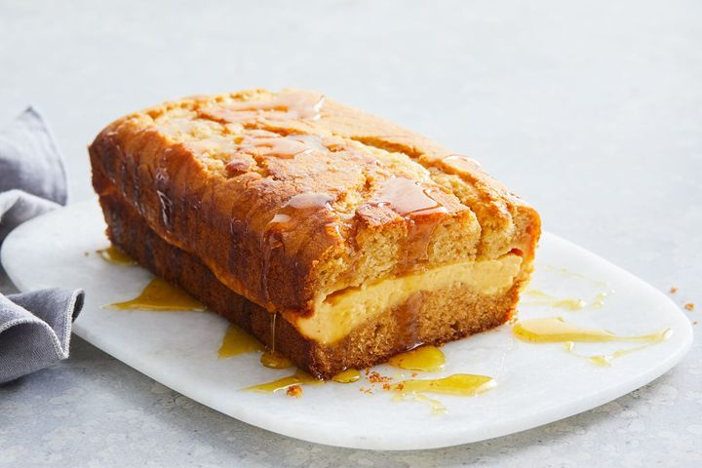](https://www.taste.com.au/recipes/nannas-golden-syrup-custard-cake-recipe/ktcy7b1z?r=baking/g56nlfz4)**

# 1[Nanna's golden syrup custard cake](https://www.taste.com.au/recipes/nannas-golden-syrup-custard-cake-recipe/ktcy7b1z?r=baking/g56nlfz4)

Just the way Nanna used to make it, this easy cake will become your go-to afternoon or weekend treat. You'll love the creamy custard centre and sticky golden syrup drizzle.

# 2[Plum and coconut slice](https://www.taste.com.au/recipes/plum-coconut-slice/5dTVMq5H?r=baking/g56nlfz4)

This plum and coconut slice will take you back to afternoon tea in Grandma's kitchen.

**[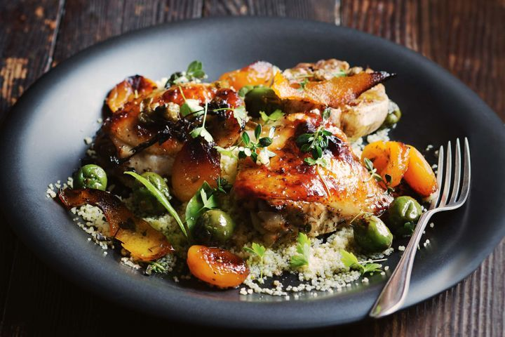](https://www.taste.com.au/recipes/apricot-chicken-3/e1d88096-a2fe-46c1-88fd-11430fe66cd8?r=baking/g56nlfz4)**

# 3[Apricot chicken](https://www.taste.com.au/recipes/apricot-chicken-3/e1d88096-a2fe-46c1-88fd-11430fe66cd8?r=baking/g56nlfz4)

"Pair sweet/tart apricots with succulent chicken and the saltiness of capers and olives for our modern take on a classic" - Matt Preston

**[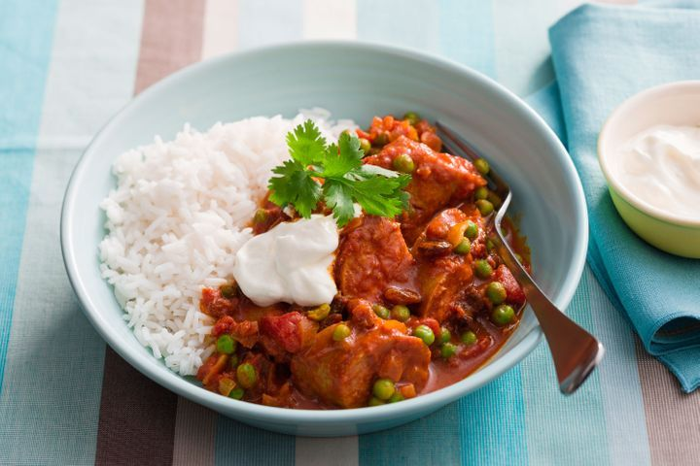](https://www.taste.com.au/recipes/grandmas-curried-sausages/47537a88-aee8-4b8e-80e1-53b49a8c0dc6)**

# 4[Grandma's curried sausages](https://www.taste.com.au/recipes/grandmas-curried-sausages/47537a88-aee8-4b8e-80e1-53b49a8c0dc6)

Nothing is as comforting as a big plate of traditional curried sausages.

**[](https://www.taste.com.au/recipes/madeira-cake/793f7da1-4c6f-4f68-a11b-50b7327d4d14)**

# 5[Madeira cake](https://www.taste.com.au/recipes/madeira-cake/793f7da1-4c6f-4f68-a11b-50b7327d4d14)

Nothing beats a good-old retro style cake to end a meal, celebrate a special occasion or simply enjoy as a scrumptious treat.

**[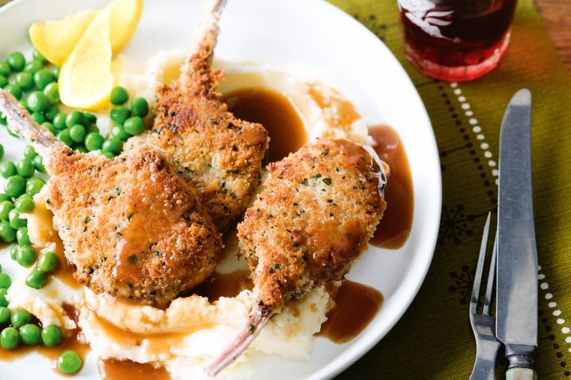](https://www.taste.com.au/recipes/classic-crumbed-cutlets/867414e5-b276-442f-816e-f1dcc9afaba3)**

# 6[Classic crumbed cutlets](https://www.taste.com.au/recipes/classic-crumbed-cutlets/867414e5-b276-442f-816e-f1dcc9afaba3)

Go retro with these classic crumbed cutlets on fluffy mashed potato.

**[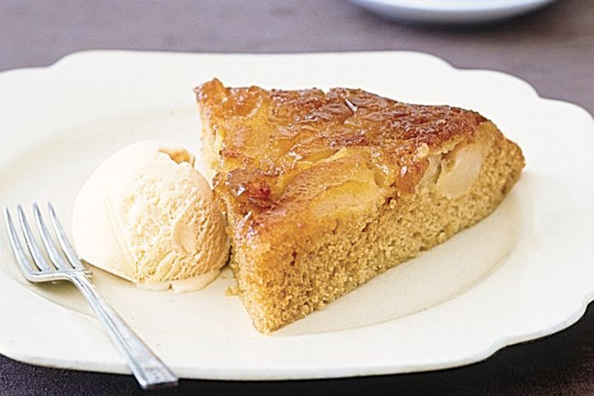](https://www.taste.com.au/recipes/pear-ginger-pan-pudding/dc55784f-15e5-4169-8006-d68f94f6caec)**

# 7[Pear and ginger pan pudding](https://www.taste.com.au/recipes/pear-ginger-pan-pudding/dc55784f-15e5-4169-8006-d68f94f6caec)

Turn pears into this aromatic baked pudding just like Nan used to make.

**[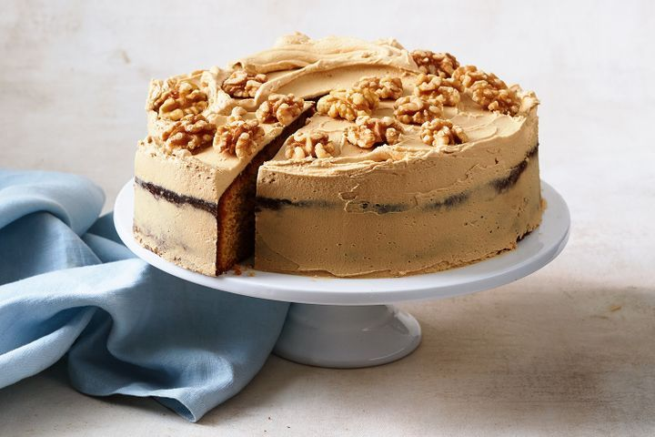](https://www.taste.com.au/recipes/ginger-cake/740ya8g3)**

# 8[Ginger cake](https://www.taste.com.au/recipes/ginger-cake/740ya8g3)

“This is a special recipe for both sides of my family. My maternal nana shared it with my paternal nana after a family event. My mother sadly passed away from cancer but the recipe will live on and be handed down to yet another generation as my daughter is expecting a baby girl!” – Julie Carrington, NSW

**[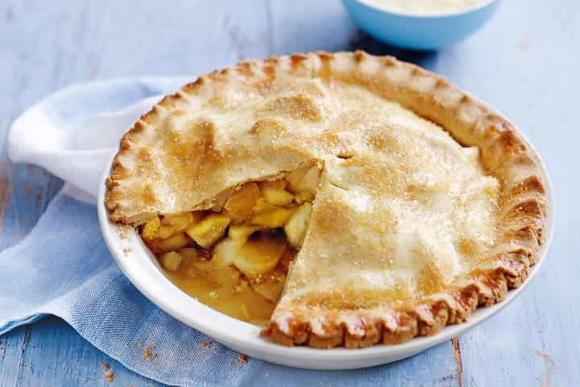](https://www.taste.com.au/recipes/classic-apple-pie/9c4de42d-7241-4dbc-8e08-d04d90a4109e)**

# 9[Classic apple pie](https://www.taste.com.au/recipes/classic-apple-pie/9c4de42d-7241-4dbc-8e08-d04d90a4109e)

Fill your kitchen with the sweet fragrance of apple pie - this one is just like Nanna's and everyone will love it!

**[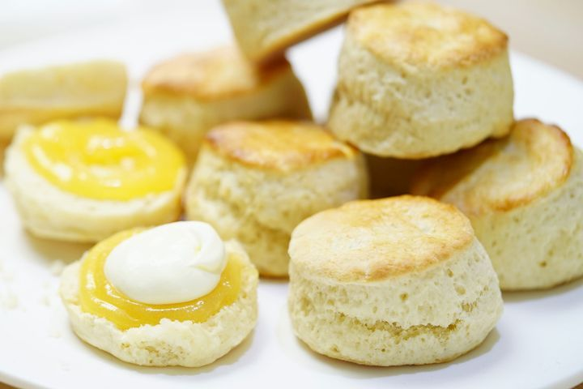](https://www.taste.com.au/recipes/lemonade-scones/292387e6-4dcf-4c72-b8e6-e903384d1c34)**

# 10[Lemonade scones](https://www.taste.com.au/recipes/lemonade-scones/292387e6-4dcf-4c72-b8e6-e903384d1c34)

This scone recipe has many fans - try it yourself and see if you're one too!

**[](https://www.taste.com.au/recipes/quiche-lorraine-3/a974cc13-168e-481a-b00d-99557544861b)**

# 11[Quiche Lorraine](https://www.taste.com.au/recipes/quiche-lorraine-3/a974cc13-168e-481a-b00d-99557544861b)

Classic quiche lorraine is great served as a starter snack or part of dinner.

**[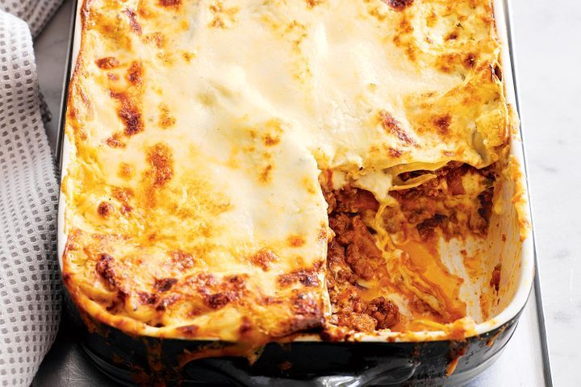](https://www.taste.com.au/recipes/classic-lasagne-2/e90c2125-a3f8-4f3e-8776-d22fcbd10c5e)**

# 12[Classic lasagne](https://www.taste.com.au/recipes/classic-lasagne-2/e90c2125-a3f8-4f3e-8776-d22fcbd10c5e)

Buffalo mozzarella and parmesan cheese make this traditional lasagne extra cheesy.

**[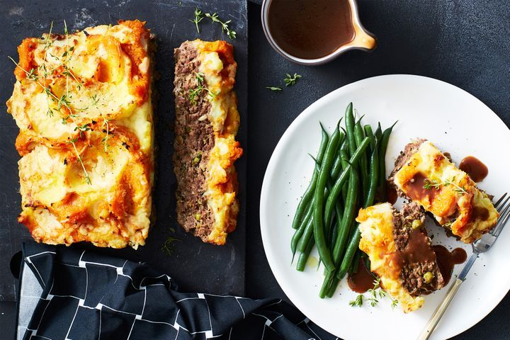](https://www.taste.com.au/recipes/roast-dinner-meatloaf/5yhsipk3)**

# 13[Roast dinner meatloaf](https://www.taste.com.au/recipes/roast-dinner-meatloaf/5yhsipk3)

We've turned the classic roast dinner into all-in-one dinner meatloaf, featuring a savoury beef mince base and a creamy potato and pumpkin mash topping.

**[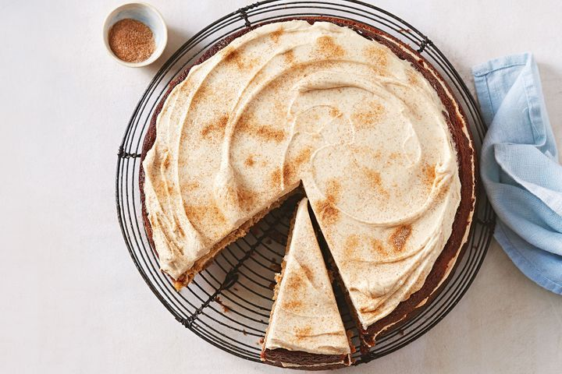](https://www.taste.com.au/recipes/spiced-cake-cinnamon-sugar-icing/qp9i62e9)**

# 14[Spiced cake with cinnamon sugar icing](https://www.taste.com.au/recipes/spiced-cake-cinnamon-sugar-icing/qp9i62e9)

A scrumptious 'nanna style' cake made with cinnamon, ginger, nutmeg and sour cream. Perfect with a cup of tea.

**[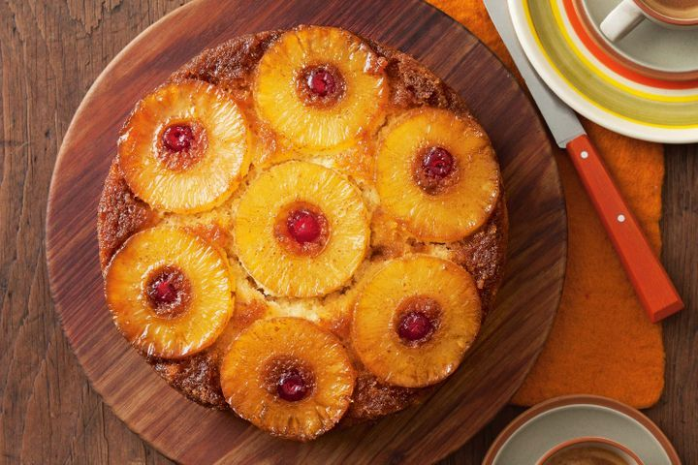](https://www.taste.com.au/recipes/pineapple-upside-down-cake-4/1b6b78bb-9f70-4020-8b7b-3627c8926cae)**

# 15[Pineapple upside-down cake](https://www.taste.com.au/recipes/pineapple-upside-down-cake-4/1b6b78bb-9f70-4020-8b7b-3627c8926cae)

Take a step back in time as you rediscover this tropical tutti-frutti favourite cake recipe.

**[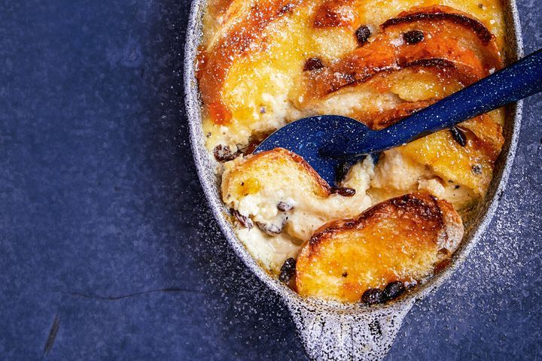](https://www.taste.com.au/recipes/classic-bread-butter-pudding-recipe/jsz0wk3m)**

# 16[Classic bread and butter pudding](https://www.taste.com.au/recipes/classic-bread-butter-pudding-recipe/jsz0wk3m)

For the perfect cosy dessert to devour on a night in, you can't look past classic bread and butter pudding.

**[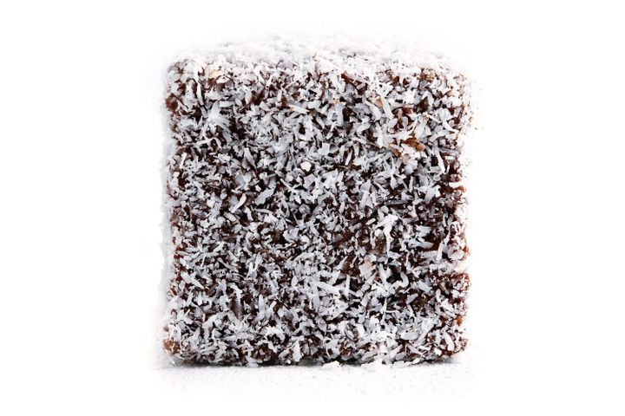](https://www.taste.com.au/recipes/classic-lamingtons/88871e61-74b7-49a2-89e4-2f316ac54592)**

# 17[Classic lamingtons](https://www.taste.com.au/recipes/classic-lamingtons/88871e61-74b7-49a2-89e4-2f316ac54592)

It's hard to resist this much-loved Australian classic.

**[](https://www.taste.com.au/recipes/classic-baked-vanilla-cheesecake/2c52456a-9a15-4a56-a285-b6e3ef2c6e4d)**

# 18[Classic baked vanilla cheesecake](https://www.taste.com.au/recipes/classic-baked-vanilla-cheesecake/2c52456a-9a15-4a56-a285-b6e3ef2c6e4d)

Smooth, creamy and with a hint of vanilla - this classic cheesecake is hard to beat.

**[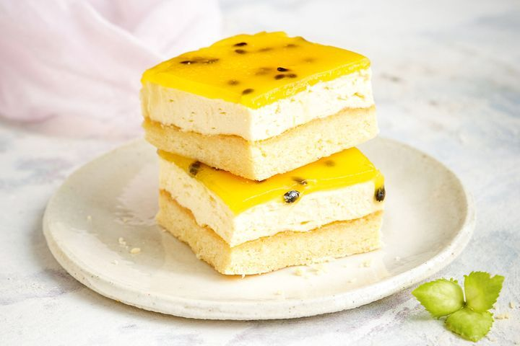](https://www.taste.com.au/recipes/passionfruit-coconut-vanilla-slice-recipe/9yuokqlx)**

# 19[Passionfruit coconut vanilla slice](https://www.taste.com.au/recipes/passionfruit-coconut-vanilla-slice-recipe/9yuokqlx)

We've given classic vanilla slice a twist with coconut, white chocolate and a passionfruit glaze.

**[](https://www.taste.com.au/recipes/classic-scones-jam-cream/8e15a7c3-cbc8-4a5e-8484-161b319128eb)**

# 20[Classic scones with jam and cream](https://www.taste.com.au/recipes/classic-scones-jam-cream/8e15a7c3-cbc8-4a5e-8484-161b319128eb)

Try your hand at freshly made scones. Work quickly and lightly, being mindful not to overwork the dough.

**[](https://www.taste.com.au/recipes/melting-moments-3/e4fc6a71-a39e-4822-8d3e-4b90230e75ab)**

# 21[Melting moments](https://www.taste.com.au/recipes/melting-moments-3/e4fc6a71-a39e-4822-8d3e-4b90230e75ab)

For a simple sweet treat try these delicious melting moments with raspberry puree!

**[](https://www.taste.com.au/recipes/classic-finger-buns/22964ae7-cdf6-4b59-aa87-7d94c7abbf37)**

# 22[Classic finger buns](https://www.taste.com.au/recipes/classic-finger-buns/22964ae7-cdf6-4b59-aa87-7d94c7abbf37)

Remake the classic finger bun in a few simple steps.

**[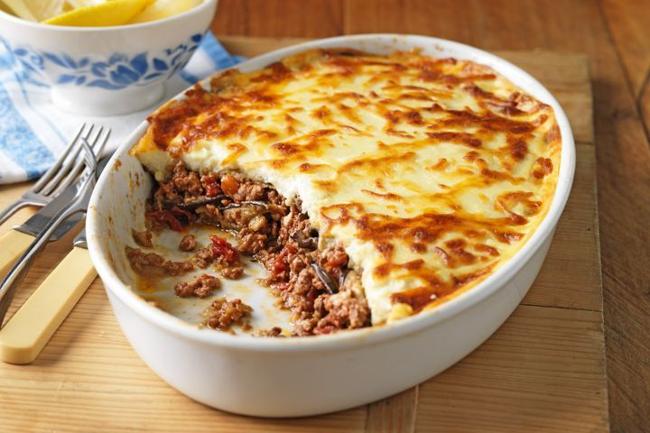](https://www.taste.com.au/recipes/classic-moussaka/88513a78-4b3d-4546-b985-32f4c33382a7)**

# 23[Classic moussaka](https://www.taste.com.au/recipes/classic-moussaka/88513a78-4b3d-4546-b985-32f4c33382a7)

This signature Mediterranean dish featuring succulent lamb mince topped with creamy bechamel sauce is perfect for your next family feast.

**[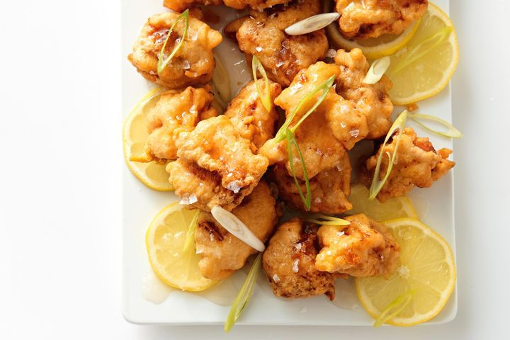](https://www.taste.com.au/recipes/old-school-lemon-chicken/ae218f42-417b-48ef-bffc-fe6c458739df)**

# 24[Old-school lemon chicken](https://www.taste.com.au/recipes/old-school-lemon-chicken/ae218f42-417b-48ef-bffc-fe6c458739df)

Try this favourite Chinese takeout recipe at home and turn it into a family classic.

**[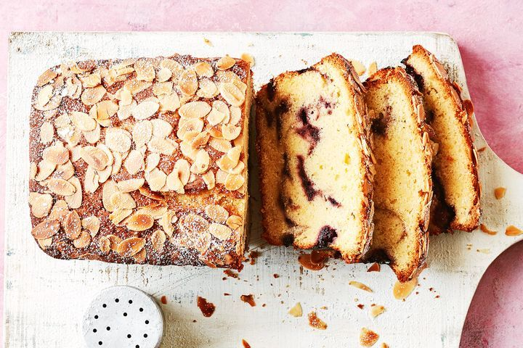](https://www.taste.com.au/recipes/blackberry-ripple-madeira-cake/lp6ut9lg)**

# 25[Blackberry ripple madeira cake](https://www.taste.com.au/recipes/blackberry-ripple-madeira-cake/lp6ut9lg)

The classic maderia cake gets a new look with a blackberry sauce ripple and crispy almond topping.

**[](https://www.taste.com.au/recipes/classic-custard-tarts/d6dd312f-30df-4194-8c79-e9f3d8c5247a)**

# 26[Classic custard tarts](https://www.taste.com.au/recipes/classic-custard-tarts/d6dd312f-30df-4194-8c79-e9f3d8c5247a)

Who can go past a crunchy pastry protecting a centre of eggy custard.

**[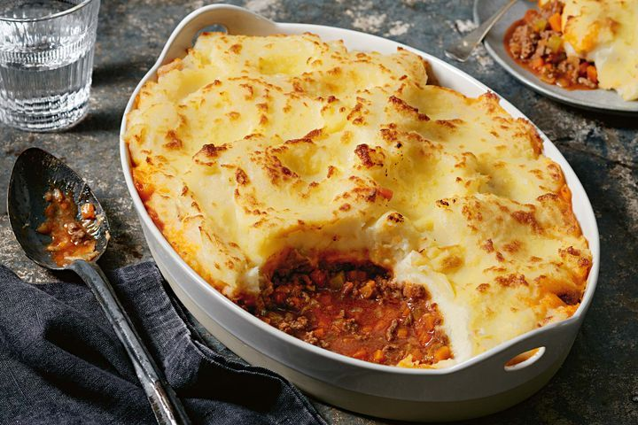](https://www.taste.com.au/recipes/curtis-stones-granny-cottage-pie/BHlSfKMl)**

# 27[Curtis Stone's granny's cottage pie](https://www.taste.com.au/recipes/curtis-stones-granny-cottage-pie/BHlSfKMl)

“Sometimes you just feel like a classic comfort meal. This hearty dish is pretty special to me – my Granny used to make it for me and my brother.” – Curtis

**[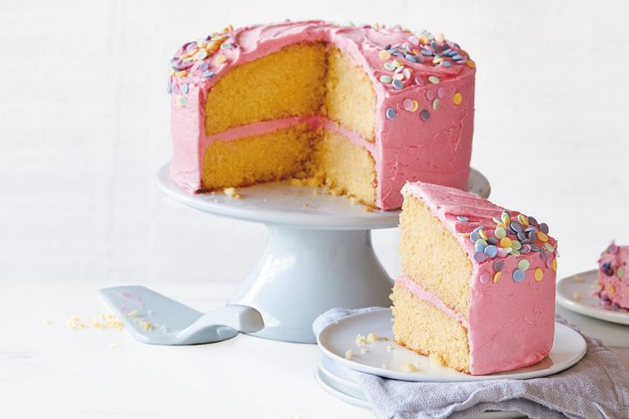](https://www.taste.com.au/recipes/classic-butter-cake/5rglnq5k)**

# 28[Classic butter cake](https://www.taste.com.au/recipes/classic-butter-cake/5rglnq5k)

Serve a classic favourite with this basic butter cake recipe. This moist vanilla sponge is topped with a versatile creamy vanilla buttercream icing and rainbow sprinkles.

**[](https://www.taste.com.au/recipes/vanilla-slice/14b24297-d3d5-405e-bef8-bbe62e8c64bc)**

# 29[Vanilla slice](https://www.taste.com.au/recipes/vanilla-slice/14b24297-d3d5-405e-bef8-bbe62e8c64bc)

Reminisce with a childhood favourite with this classic vanilla slice recipe.

**[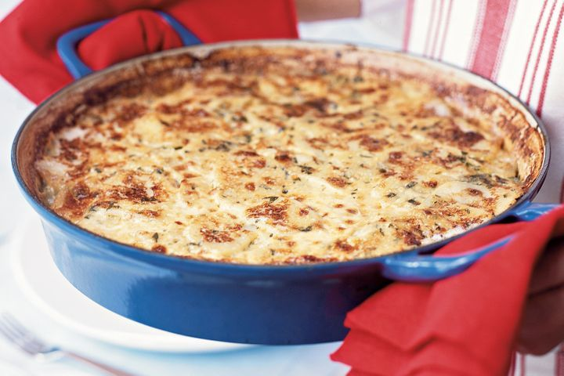](https://www.taste.com.au/recipes/potato-leek-gratin/8c4d15b4-c2d0-435f-964d-785fcc530198)**

# 30[Potato and leek gratin](https://www.taste.com.au/recipes/potato-leek-gratin/8c4d15b4-c2d0-435f-964d-785fcc530198)

Go retro with this classic gratin.

**[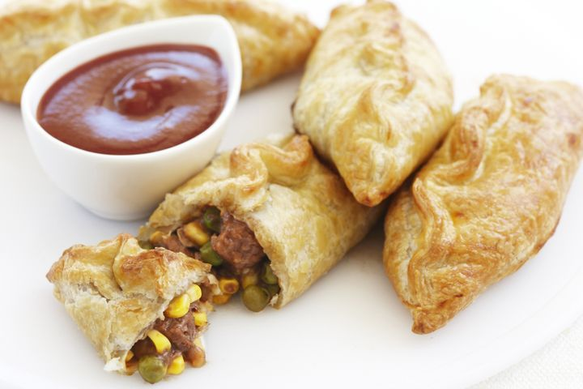](https://www.taste.com.au/recipes/beef-vegetable-pasties/b2b3d4d4-aaff-4aab-ad5c-c56cc237c9ae)**

# 31[Beef & vegetable pasties](https://www.taste.com.au/recipes/beef-vegetable-pasties/b2b3d4d4-aaff-4aab-ad5c-c56cc237c9ae)

Puff pastry filled with beef, corn and peas makes for a hearty lunch or snack option.

**[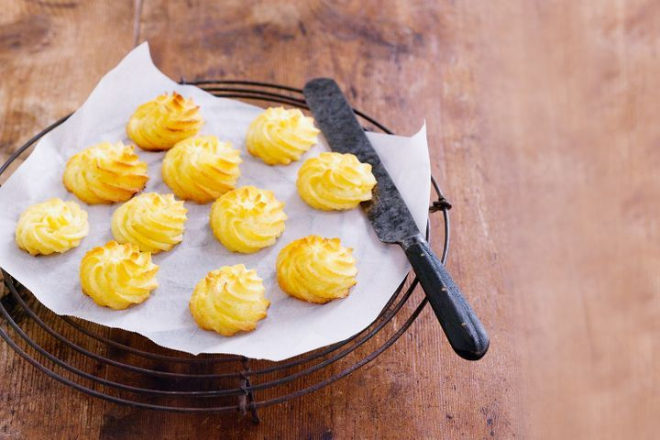](https://www.taste.com.au/recipes/duchess-potatoes-2/53d589a6-6c2e-4817-bd47-791cf57acbab)**

# 32[Duchess potatoes](https://www.taste.com.au/recipes/duchess-potatoes-2/53d589a6-6c2e-4817-bd47-791cf57acbab)

This side will satisfy - it's warm, hearty and full of classic memories.

**[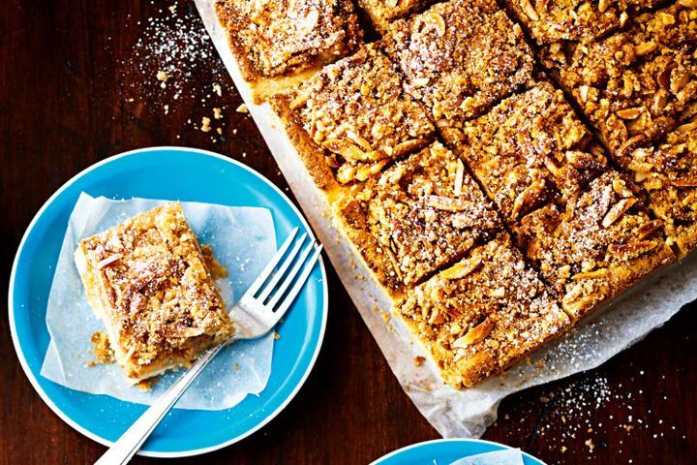](https://www.taste.com.au/recipes/apple-crumble-slice-3/5ff57afe-8d88-4fe5-b91d-ee9c1da61a85)**

# 33[Apple crumble slice](https://www.taste.com.au/recipes/apple-crumble-slice-3/5ff57afe-8d88-4fe5-b91d-ee9c1da61a85)

It's like magic! We've turned traditional apple pie into a fabulous slice.

**[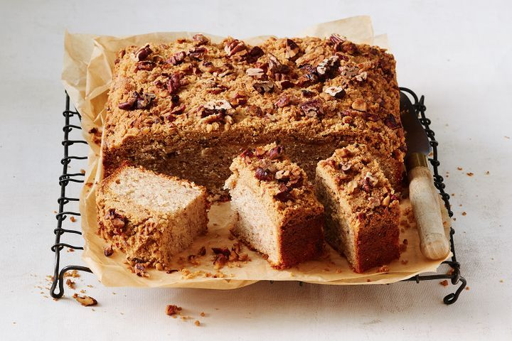](https://www.taste.com.au/recipes/banana-cake-nutty-crumble-topping/z16vcciv)**

# 34[Banana cake with a nutty crumble topping](https://www.taste.com.au/recipes/banana-cake-nutty-crumble-topping/z16vcciv)

“This humble banana cake reminds me of my mum and my 1950s childhood. The war-era recipe is like no other and the cake has a delicious nutty caramel topping, which makes it really special.” – Ann Leray, SA

# Christmas countdown calendar: what to do at 3 weeks

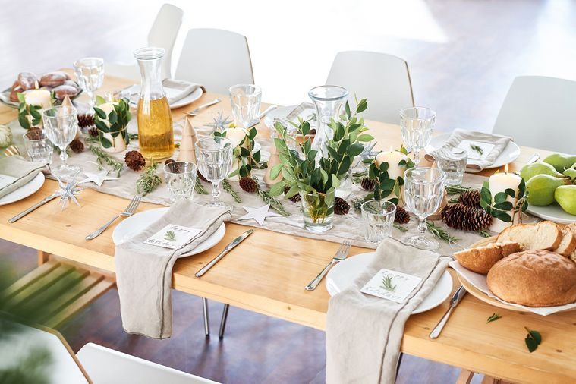

**We've got your back.**

## ****Write a master shopping list****

Pen a list of all the holiday events you’ll need to stock up for – that includes Christmas Eve, Christmas Day and any Boxing Day soirees or summer barbecues that have crept into the diary. If you’re entertaining more than once (breathe!), this is a good way to find crossover paths: you know, multiple dishes for that haul of cherries? This [cherry chocolate pudding cake](http://www.delicious.com.au/recipes/collections/gallery/celebrate-cherry-season-these-22-recipes/0dxn17pF?page=4) screams summer, as do these fun and fruity [watermelon, cherry and raspberry pops](http://www.delicious.com.au/recipes/collections/gallery/celebrate-cherry-season-these-22-recipes/0dxn17pF?page=6) for the kids the next day.

## ****Stock up on all non-perishables****

Now’s the time to finish the non-perishable side of the shopping: all those crisps, crackers, sparkling water and cheese-board accompaniments. When it comes to crafting that [Insta-worthy cheese board](http://www.delicious.com.au/food-files/how-to/article/create-instagram-worthy-cheese-platter/GYWbuXU1), think seasonally (we’re looking at you again, cherries – but best to add these to the perishables list! More on that later.) And go for what’s on special. Grissini sticks, nuts, dried fruit and rolled-up deli meats (again, a perishable) will make it a board to remember.

## ****Do a baking stocktake****

So your Christmas baking Pinterest board is 694 pins deep and your baking books are overflowing with Post-its. We hate to be the bearer of bad news, but it’s unlikely you’re going to get through all those must-bakes in one season. Sorry! Start condensing those lists into one achievable one – we’re not saying ditch that 12-tiered showstopper, but maybe limit it to the one knockout bake and a few supporting roles. Or take it back to the classics with a Christmas pav. As for the rest? Delegate to celebrate!

Team Fruitcake or Pav? Either way, we’ve got you sorted with this [*collection of Christmas desserts.*](http://www.delicious.com.au/recipes/collections/treat-yoself-christmas-dessert-collection/1541a315-720b-4486-a8fa-0834bd48953a)

## ****Shop for your out-of-town loved ones****

If you’re planning that special little Santa parcel for that friend or family member abroad, now’s the time to ship it. If they’re an Aussie away from home, a sentimental best-of box will hit the sweet spot – Tim Tams, Caramello Koalas, Vegemite, Milo, Iced VoVos… And don’t forget the card! Speaking of… **Get those holiday cards out the door!**

If you’ve opted for snail mail, now’s a great time to mail them. That way, they’ll get the most Christmas decoration mileage at the other end – you know, dressing mantles, blinds, Christmas trees, etc.

## ****Cook up a last-minute batch of freezer meals****

The end of year wind-up often means late nights in the office and a social diary that’s so crammed there’s barely time to eat. A little forward planning will go a long way in fending off the take-out monster and potentially safeguard the fragile old holiday immune system. If you’ve already burned through your first batch of frozen meals, set aside a day for a round two cook-up. And, no, freezer meal does not translate to five kilos of spag bol – try our [sausage meatballs with chickpeas](http://www.delicious.com.au/food-files/how-to/article/create-instagram-worthy-cheese-platter/GYWbuXU1) or [vegetarian mushroom and silverbeet lasagna](http://www.delicious.com.au/recipes/vegetarian-mushroom-silverbeet-lasagne/AmBeAqrT?current_section=recipes&adkit_ref=/recipes/collections/ultimate-freezer-friendly-recipes/wiEF6JVK) instead.

## ****Pick up a few just-in-case gifts****

That awkward moment when a friend unexpectedly hands you a beautifully wrapped parcel and you have nada for them in return can be avoided with a few pre-purchased and pre-wrapped goodies. Boxes of chocolates, scented candles, pre-packaged Christmas puds and fruit mince pies are great to have on hand to save the day. You’re welcome.

# Christmas countdown calendar: what to do at 4 weeks

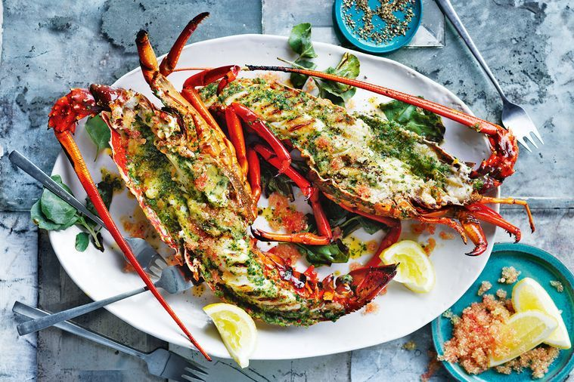

Grilled king island crayfish.

**There are 26 days until Christmas. If you just used an expletive out loud, it’s time to read our Christmas planner and save yourself those undue bags under the eyes later.**

## ****Be sure to cater for everyone****

You’ve already drafted a menu, but does it take into account all those specific dietary requirements? Vegetarian, vegan, dairy-free… there’s likely to be at least one guest who will appreciate the special thought you’ve given them during the festivities. And if you thought that ‘vegetarian’ limited you to mushroom risotto, or vegan equals salad – it’s time to consult our [vegan Christmas menu planner.](http://www.delicious.com.au/recipes/collections/gallery/35-recipes-ultimate-vegan-christmas) From Silvia Colloca’s vegan lentil and sweet potato chickpea stew to a delicious tomato paella, prepare to have your worlds rocked, carnivores.

## ****Don’t forget your gluten-free mate or cousin!****

Step aside fruit platter; whether it’s sweet or savoury, there are a bevvy of gluten-free options to feast on during the holidays. This [roast pork with pistachio stuffing](http://www.delicious.com.au/recipes/group/gallery/36-easy-recipes-gluten-free-christmas/rsG9JSCc?page=2) is easy for coeliacs and gluten intolerants alike to digest, while a [garlic and cheese pull-apart](http://www.delicious.com.au/recipes/group/gallery/36-easy-recipes-gluten-free-christmas/rsG9JSCc?page=7) will sate all those bready cravings. And these ultra-festive [buckwheat and ginger reindeer biscuits](http://www.delicious.com.au/recipes/buckwheat-ginger-reindeer-biscuits/95e0baca-db9d-4812-916b-2b05fddedb1c?current_section=recipes) will add some cheer to any Christmas spread.

Get more gluten-free Christmas inspiration [*here*](http://www.delicious.com.au/recipes/group/gallery/36-easy-recipes-gluten-free-christmas).

## ****Get pickling and preserving****

Nothing screams thoughtfulness (not to mention saves those precious pennies) like a handmade gift. If you’ve been scarred by one too many failed baking attempts in years gone by, give pickling or preserving a go this year. There’s nothing more festive than a pretty jar filled with something bright and tasty, finished with ribbon and a special little thought on a tag. [Homemade strawberry jam](http://www.delicious.com.au/recipes/homemade-strawberry-jam/4d9c4865-a42a-458c-a8bc-0d36f9ceace9?current_section=recipes) will always receive a smile in return, as will a jar of [pickled baby carrots](http://www.delicious.com.au/recipes/pickled-baby-carrots/aba899d0-5aa6-4917-841c-e15ff3588a86?current_section=recipes&adkit_ref=/recipes/collections/pickle-preserve-recipes/4beb5c8b-3fe9-4bac-8c88-e215eed34ab4). The best thing about pickles and preserves is that they can be made weeks ahead – four weeks, even. Be sure to keep a jar of whatever you make for your own Christmas Day spread.

## ****Choose your meat****

If you haven’t already, now’s the time to get this one out of the way. Once you’ve chosen your mains, it will pave the way for you to decide on all your sides, salads and condiments. Hams and turkeys are ageless showstoppers (who doesn’t want to be that smug person emerging from the kitchen with a perfectly glazed and studded ham leg?), but if you want to cook outside the box this year, try this light and summery [poached rolled chicken with mango and chilli chutney](http://www.delicious.com.au/recipes/poached-rolled-chicken-mango-chilli-chutney/e468c846-ea5c-46bf-8504-8e55816d2724?current_section=recipes&adkit_ref=/recipes/collections/alfresco-christmas/0e6c9cf9-0616-48bb-9821-38a1726e9ee2); it’ll knock their socks off.

Get more ideas for [*Christmas mains.*](http://www.delicious.com.au/recipes/collections/main-event-christmas-mains-sorted)

## ****Decide on your seafood****

It wouldn’t be a Southern Hemisphere Christmas if there wasn’t some of the ocean’s bounty on offer. Cold seafood is always a time and resource-light option to have prepped ahead, not to mention the ideal accompaniment to all those Christmas tipples. Breathe new life into the classic prawn cocktail with this [out-of-the-glass option](http://www.delicious.com.au/recipes/daring-out-glass-prawn-cocktail-breaks-rules/c33d21ac-0ff4-4bea-9b4a-503decaa1c4e?current_section=recipes) (haven’t you heard? Everything old is new again!), or simply serve up a platter of freshly shucked oysters with lemon wedges and a couple of vinaigrettes. For the ultimate jaw-dropper, this [grilled crayfish with saltbush butter](http://www.delicious.com.au/recipes/grilled-king-island-crayfish-saltbush-butter/mpVqcohA) will do the trick. Here are more[festive seafood ideas.](http://www.delicious.com.au/recipes/collections/christmas-seafood-collection)

## ****Plan to keep the oven turned off this year****

Before you conclude that we’ve totally lost our holiday marbles (Christmas carols on repeat can do that) – hear us out: there’s no reason your entire Christmas spread can’t be made in the fridge or on the barbie. Imagine that: a party spent outside or in the company of your loved ones rather than sweating it up in the kitchen. This [barbecued lobster](http://www.delicious.com.au/recipes/barbecued-lobster/b121a598-46e2-43a6-9845-0b74823fd72a?current_section=recipes&adkit_ref=/recipes/collections/christmas-seafood-collection/45d32504-1d46-4ac5-93c1-c3460b1350f8) is both festive and simple, while these [barbecued prawns with quick aioli](http://www.delicious.com.au/recipes/barbecued-prawns-quick-aioli/57ff9b1f-4f82-4c62-8598-00f6714656d4?current_section=recipes) are the ultimate express pass-about. When it comes to the sweet stuff, opt for a no-bake treat like delicious.’s cult classic, the [mangomisu](http://www.delicious.com.au/recipes/mangomisu-mango-tiramisu/7f8fea08-4b46-4f04-9f2b-3e95a547e80a?current_section=recipes&adkit_ref=/recipes/collections/no-bake-dessert-recipes/ec8dfb63-167e-4a00-b428-591ae97d2cf3), or this decadent no-bake [gingerbread trifle](http://www.delicious.com.au/recipes/gingerbread-trifle/Z3E82GKY?current_section=recipes), ready in less than 30 minutes. Until next time, oven.

# The price of milk is set to increase as Aussie farmers battle floods and rising costs



**As the cost of living crisis worsens, the price of this household staple continues to rise. Words by Isabel McMillan.**

The price of a staple household item has gone up by 30c in less than a year, but experts predict it’ll spike again by the end of 2022. By the end of 2021, home-branded milk in Australian supermarkets would have set you back $1.30. But now it’s reached $1.60, prompting investigations into why the price has risen, and whether or not the trend will continue.

As floods continue to wreak havoc across Victoria, NSW and parts of Tasmania, and the global economy conditions worsen, we can expect to see the price of milk rise in the foreseeable future.

The Australian Bureau of Agricultural and Resource Economics and Science (ABARES) projected a 28 per cent increase in the farmgate [milk](https://www.delicious.com.au/recipes/collections/gallery/42-recipes-with-coconut-milk/3yimr8yl) price going into 2023, raising it to 72.5 cents per litre. The farmgate milk price is what dairy farmers are paid for the milk they produce.

A big contributing factor to the price increase is a decrease in production, which has been on the decline since 2014. With higher demand and lower supply, the price is driven up higher.



***Related story:***[***How much for lettuce?! Why interest rates and La Niña are making grocery prices higher***](https://www.delicious.com.au/food-files/news-articles/gallery/why-interest-rates-la-nina-making-grocery-prices-higher/29946zt0)

In weather-affected communities, stock is flying off the shelves, adding more pressure to the dairy industry to produce more. Within the first six months of this year, milk production was seven per cent lower than the first half of 2021, according to ABARES.

The extreme weather events caused by La Nina and the Indian Ocean Dipole across Australia this year have limited production nationwide.

Dairy farmers have done it tough over the past few years, first battling to overcome challenges brought about by the pandemic, and then the devastation in Ukraine which has seen [costs](https://www.delicious.com.au/recipes/collections/gallery/budget-recipes/yhstq15q) of supplies skyrocket.

Add in the flooding and natural disasters, and it’s no wonder the industry has decreased from around 7,500 dairy farmers down to 5,700.

The farmgate milk prices were regulated up until July 2000, after which farmers were free to negotiate their own terms with buyers. The issue this now brings is Australian dairy producers will sell their milk to a handful of processors, who then go on to sell to only a few select retailers, with 60 per cent of total milk sales coming from major supermarkets.



This became an issue in 2011 as Coles tried to corner the market by offering milk for $1 per litre – which worked until Woolworths and Aldi joined the cause, and this made milk prices stay incredible low for nearly a decade. Milk processors needed the bigger supermarket contracts, so they had no choice but to squeeze the dairy farmers, and many of them gave up farming because of it. Dairy production peaked in 2014 and has since been declining from then.

The major supermarkets ended the $1/L [milk](https://www.delicious.com.au/recipes/collections/gallery/7-creamy-recipes-leftover-dairy/t4gzjord) sales in 2019 after public outcry and political pressure forced them to acknowledge it was having detrimental effects. A 28 per cent rise in the farmgate prices going into the new year will reportedly bring the value of milk production in Australia to $6.2 billion, finally giving some hope to dairy farmers who have been doing it tough for a very long time.

*This article originally appeared on*[*news.com.au*](https://www.news.com.au/lifestyle/food/milk-prices-to-spike-as-farmers-battle-floods-pandemic-cost-of-living/news-story/34e9512d46d0f8f084d6ce7acc60ffd0)*. It has been reproduced here with permission.*

# Matt Preston shares his cost-effective meal ideas to help you save on the weekly shop

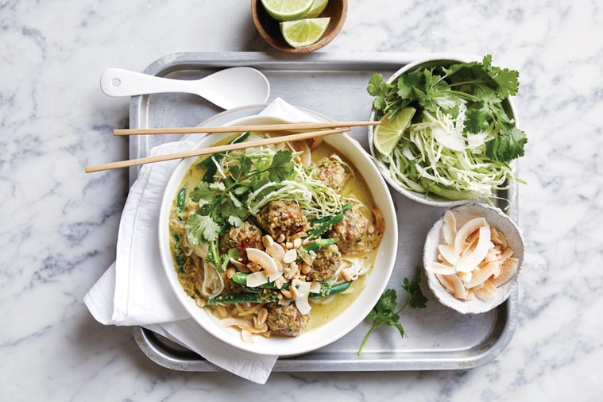

**Matt Preston shares his tips for flavour-packed midweek meals that go easy on the hip pocket.**

Money is tight, time is poor and we all need some inspiration for those nightly dinners. Here’s my simple primer to midweek feeds that cost less, beat stress and bring more tasty fun.

## ****PASTA & NOODLES****

The deal with any bland carb is to bombard it with maximum flavour, whether that’s fish sauce, chilli or soy sauce, [pork](https://www.delicious.com.au/recipes/collections/gallery/22-ways-with-pork-belly-for-the-festive-season/7bwbhmk9) fat, anchovies or olives. While I love the ease of noodle dishes that rely on pantry staples like a laksa or stir-fry, these can all be improved with seasonal, and therefore cheaper, produce. Or for a budget spaghetti arrabbiata, spike the simplest of tomato sauces (tinned tomato, olive oil, garlic) with dried chilli, and top with golden pangrattato made with leftover breadcrumbs.

## ****RICE****

Whether you’re making Portuguese-inspired wet rice with prawns, a simple risotto or your own “special fried”, the rules are the same as pasta. Bombard it with flavour. Risotto, while sounding cheap, can rack up the dollars with all the butter and cheese you need, so maybe look to old-school pilafs instead. Here again, adding something a little luxe like good parmesan or fancy lap cheong [sausage](https://www.delicious.com.au/recipes/collections/gallery/46-incredible-recipes-for-the-humble-sausage/yil20vmy) is a way of deflecting from everything else that’s helping balance the budget. Don’t forget the frozen corn and peas if you want to bring cheap pops of freshness.

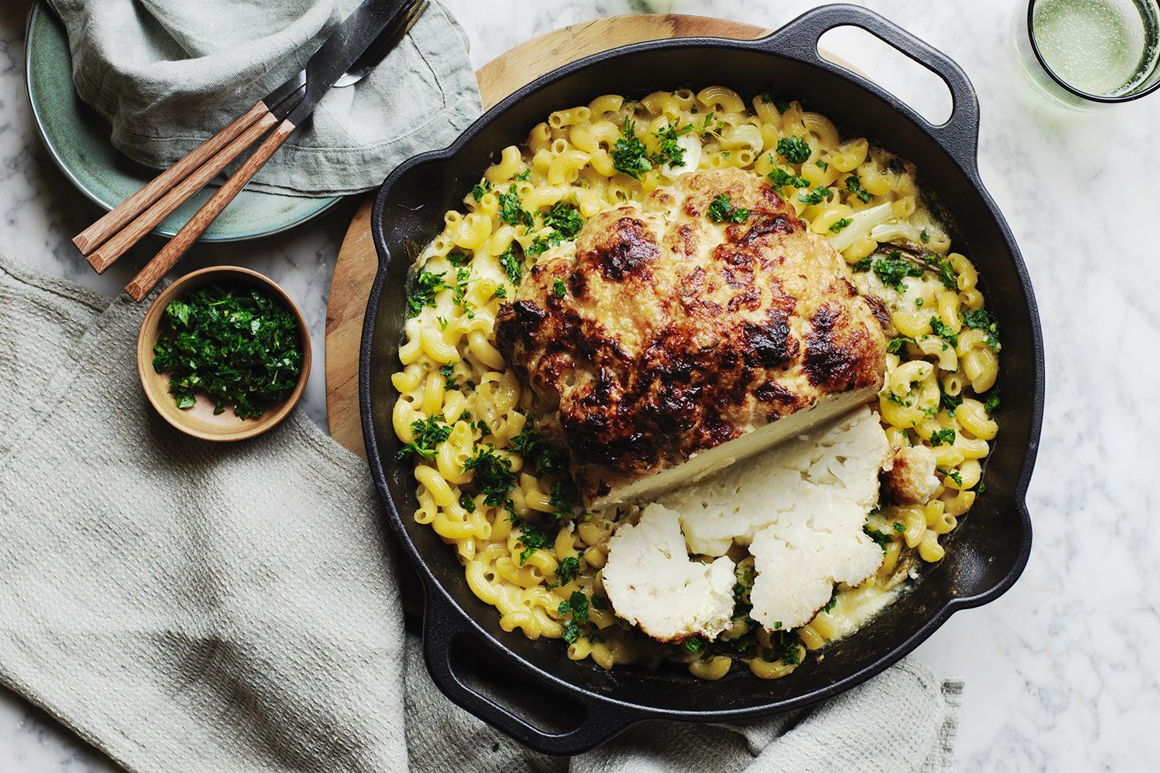

***Related story:***[***Fair dinkum! Matt Preston reveals his favourite true blue Aussie food inventions***](https://www.delicious.com.au/food-files/news-articles/article/matt-preston-reveals-favourite-australian-food-inventions/a1h7152f)

## ****VEGETABLES****

The simplest way to make cheaper veg more interesting is generally to roast it, whether as [whole roasted cauliflower](https://www.delicious.com.au/recipes/whole-roasted-cacio-e-pepe-cauliflower-recipe/ndc109mw) rubbed with harissa, oil and cumin seeds to serve with hummus, chopped dates, mint and yoghurt; or roasted carrots, beetroot or cauliflower florets in a couscous salad served with slow-roasted lamb shoulder. [Potatoes](https://www.delicious.com.au/recipes/collections/gallery/100-recipes-that-prove-potatoes-arent-bad-for-you/fmhucdsg) can be baked in their skin, turned into a creamy gratin, roasted to golden perfection or loaded with fried onions, eggs and chorizo. But a rich mash is the greatest, especially when combined with equally rich braises of cheaper cuts of meat. To minimise the mountains of butter and cream that top chefs like to throw at their mash, take clean potato peelings and infuse into milk to make a starchy, creamy addition instead. Remember that mash can be home to fresh herbs, sliced long green shallots or leftover cheese bits for a cheat’s aligot, too.

## ****MEAT****

It’s hard to go past slow-roasted pork belly or chicken thighs. Of course, there are other cheap options like ragu, grilled thinly sliced pork neck in tacos or rosemary and lemon marinated forequarter chops on the barbecue. However, none of these can compete with the lure of mince, whether that’s in bolognese, chilli, burgers or meatballs. But don’t be limited to the familiar; there’s much joy to be had from sweet and sour pork meatballs, or using chicken mince to make my Thai-style green curry meatballs.

# Banging news! You can now get an old fashioned cocktail in snag form

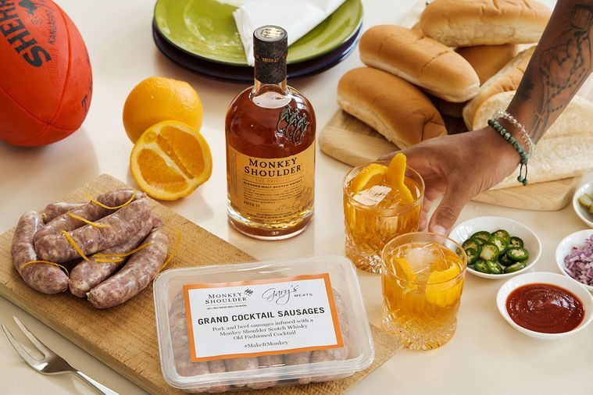

**Planning a footy finals viewing party? Get ready to have your drink and eat it too.**

If you’re looking for the perfect snack to serve up during your weekend AFL or NRL [Grand Final](https://www.delicious.com.au/recipes/collections/gallery/28-pie-recipes-that-have-you-covered-for-the-grand-final/44z08wdj?page=2) party, look no further.

Iconic whisky brand Monkey Shoulder has teamed up with Gary’s Quality Meats to create a banging new snag that brings the bar to you – the Grand Cocktail Sausage.

These pork and beef sausages are infused with all of the ingredients that make up an Old Fashioned – Scotch whisky, bitters, sugar syrup and orange zest – so yes, you’ll technically be drinking a cocktail in [sausage](https://www.delicious.com.au/recipes/collections/gallery/46-incredible-recipes-for-the-humble-sausage/yil20vmy) form.



***Related gallery:***[***43 sausage recipes that are absolute bangers***](https://www.delicious.com.au/recipes/group/gallery/sausage-recipes-pizza-pasta-thai-salad/e8qdkc8d)

Mike Lowe, Monkey Shoulder Brand Manager, says: “We love putting a Monkey twist on everything we do, just like creating a one-of-a-kind whisky wiener to celebrate the footy finals.

“Our Monkey Shoulder Grand [Cocktail](https://www.delicious.com.au/recipes/collections/gallery/kick-start-the-weekend-with-these-50-cocktail-recipes/mw49fdu3) sausages are sure to make your footy finals barbie an absolute banger!”

The Grand Cocktail Sausages will be available at Gary’s Quality Meats in Prahran Markets on Friday 23 and Saturday 24 September for the AFL Grand Final, and Friday 30 September and Saturday 1 October for the NRL Grand Final, retailing at $23.90 for a pack of six.

Monkey Shoulder and Gary’s Quality Meats will also be giving away 200 free snag packs to fanatic footy fans on a first in, best dressed basis – so you’d better go start the car!

# Jo Barrett appointed food director at On Island Time, Flinders Island

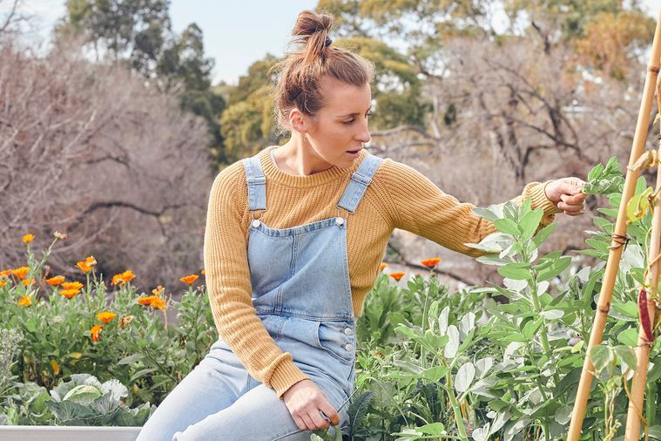

**She's running on island time now!**

Jo Barrett (ex-Oakridge, now Little Picket in Lorne) has been appointed food director at [Flinders Island’s](https://www.delicious.com.au/recipes/collections/gallery/seafood-barbecue-recipes-6-recipes-inspired-flinders-island/s7g5rupk) On Island Time, which includes bar/restaurant The Flinders Wharf and luxury accommodation at Wombat Lodge, The Crayshack and Dwarf Cottage.

Barrett has a long history with the windswept Tasmanian island. She met On Island Time founder and local Jo Youl at the Flinders Island Food & Crayfish Festival in 2018, and has been back to cook, fish and forage twice a year since.

She spent the first six months of 2022 on the ground, developing a larder-style concept for produce and finish-at-home meals like wallaby [pies](https://www.delicious.com.au/recipes/group/gallery/best-potato-pie-recipes/cex2xmfp), fresh crayfish and assorted accoutrements.

“The island is abundant with cattle and sheep farms, and wallabies run wild. Plus, fishers who head out every day to bring in line-caught fish,” Barrett says. But while there’s a lot of accommodation, there aren’t many places to eat.

***Related story:***[***Exclusive: Jo Barrett to open community restaurant Little Picket in Lorne***](https://www.delicious.com.au/eat-out/restaurants/article/jo-barrett-open-community-restaurant-little-picket-lorne/7u1il3vk)

“If you arrive on a Sunday, the pub is only open to 3pm and the supermarket is shut,” she says. “Now, when you visit, you’ll have access to tasting the island – in the past you just had to know someone.”

Barrett brings Byron Bay chef and fire-pit master Pip Sumbak with her, who takes on a six-month residency as head chef at Flinders Wharf, a sleek bar and restaurant with ocean views.

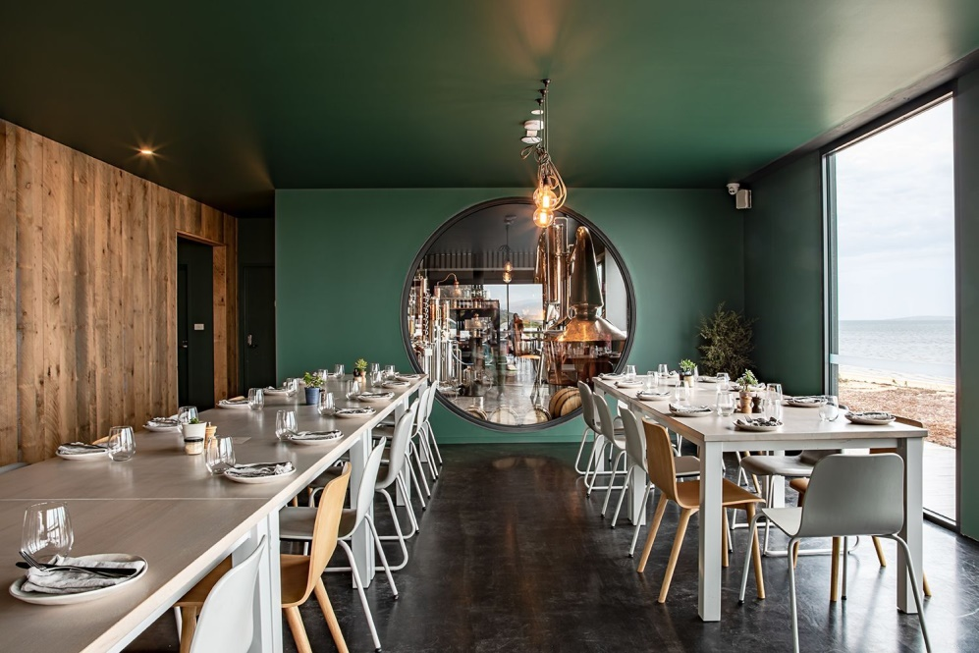

“[Pip] spent a lot of time living in Fiji, cooking in remote places for a similar combo of tourists and locals using only what’s on the island,” Barrett says. “Also, she’s probably the nicest person on the planet, so she’s going to fit in really well.”

The spring season kicks off on September 28. Visitors can collect pre-ordered supplies for their stay upon landing in Whitemark, the island’s main town.

The Flinders Wharf will open until 7pm weekdays and 1pm on weekends, with Sumbak lighting the firepits on Friday afternoons to cook huge joints of meat, [whole fish](https://www.delicious.com.au/recipes/collections/gallery/4-seafood-recipes-josh-nilands-whole-fish-cookbook/drpxrkwn) and seasonal veg.

# What Dad really wants this Father’s Day, according to Matt Preston

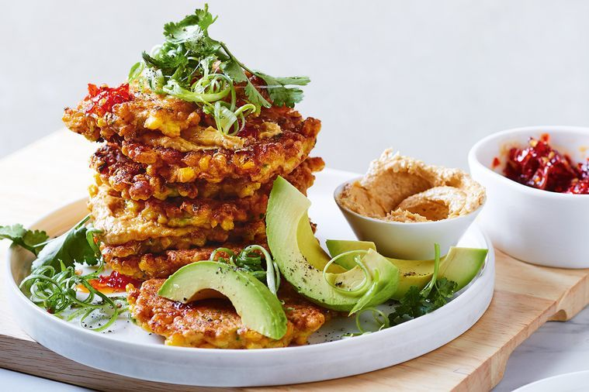

Miso almond butter corn cake stack

**Matt Preston saves Dad’s day – and your bacon, though not literally – with his insider tips for a home-cooked meal (and maybe even a homemade card).**

So you’ve forgotten today is Father’s Day. Firstly, don’t feel guilty. Quite frankly, it’s understandable that it crept up on you. Father’s Day here is months later than most of the world, with many countries marking it in June, and others in March, May, August and November. No wonder we’re confused.

And to my mind it’s also one of the lesser days of celebration here in Australia, rivalling Tartan Day and World Chocolate Day, so you can be forgiven. It’s not like forgetting Mother’s Day. Or failing to acknowledge that both these days can be very painful for those who haven’t been able to have the kids they wanted, have lost a child, or who just miss their dads.

It may not be a bad thing that you’ve forgotten. Let’s face it, even with planning, gifts like socks, DVDs on sharks or World War II, or comedy golf balls decorated with the smiling poo emoji aren’t the sort of Father’s Day gifts that most dads remember all that fondly. Or at all. Please don’t tell my kids.

Furthermore, the old stand-by of the kids making something in craft to give as a gift has waned dramatically since the creating and giving of ashtrays by children became frowned upon. The trouble was, whatever the kids tried to make in clay – a cup, jug, vase, coffee pot, whatever – it always ended up looking like a gaudy ashtray anyway. This is a pity, if only because it used to remind us that in France, Father’s Day was introduced in 1949 just as a way for a lighter company to sell more cigarette lighters! Maybe we could repurpose the traditional clay object as a saucer for olive pits?

Whatever you do for any father figure in your life at such short notice is probably better than anything planned anyway. This can stretch beyond the beautiful, heartfelt message in a homemade card (the only Father’s Day gifts I’ve kept; they still bring a lump to my throat) to recreating those cheesy but emotional kindergarten paint handprints – which at least made a change from the kids’ sticky fingerprints on doors, all over the stainless-steel fridge, your car duco, in the cake icing… (I say this a little grumpily for fear you spot a sentimental tear welling at the memory of rediscovering these handprints in a drawer or file.)

For me, sharing a meal with the family is one of the best gifts that I can be given. This has been intensified by the isolation that so many of us have been feeling over the past few years of separations and lockdowns. Rather than breakfast – it’s a little late to plan that now – make it lunch or dinner. Put on the cherished Grand Final DVD or a documentary that includes lots of numbers to distract him while you prep or nip out to the shops.

For lunch, [corn fritters with avocado](https://www.delicious.com.au/recipes/miso-almond-butter-corn-cake-stack/cvzyrcpo) are the perfect option, if a classic roast is out of reach. The fritters are quick to cook and super tasty. While the avocado, lime juice, and perhaps a chilli-caramel drizzle are enough, if your dad is a pork-loving carnivore, he’ll love adding some bacon jam and will probably pop it on everything. (For the vegetarian or non-pork-eating  dad, you can make a chilli jam; you’ll find my red onion and chilli jam recipe [here](https://www.delicious.com.au/recipes/crisp-potato-skin-mini-cottage-pies-red-o).)

Bacon jam takes about an hour to cook and is as easy as frying 500g of rindless, smoked streaky bacon until just crispy, then frying four diced garlic cloves, a diced onion and some thyme in the rendered fat until soft and a little caramelised. Now add back the bacon, ½ cup of maple syrup, ¼ cup of brown sugar, 1/3 cup of cider vinegar, a cup of strong coffee and a chopped chipotle chilli (or some smoked paprika and a diced red chilli) and cook everything down for about an hour, until thick. Add water if it thickens too quickly and starts to catch. Finally, blitz and bottle in a sterilised jar. You’ll find my corn fritter recipe [here](https://www.delicious.com.au/recipes/miso-almond-butter-corn-cake-stack/cvzyrcpo), plus loads of other suitable [Father’s Day recipes](https://www.delicious.com.au/recipes/collections/gallery/easy-fathers-day-lunch-dinner-recipes/jl7d2zyo).

If that’s too much effort, ordering his favourite takeaway tonight and watching his favourite movie – even if it is About Time, The Notebook or The Pursuit Of Happyness – will more than suffice.

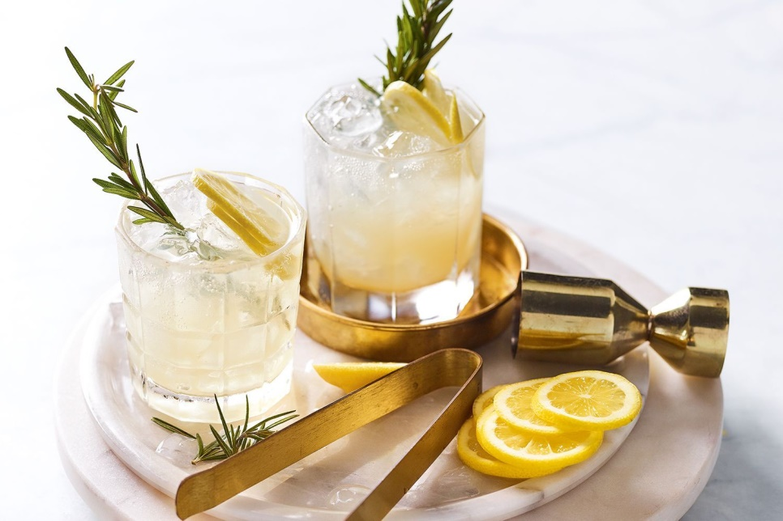

Small acts of kindness also resonate big. Take the time to make him, unprompted, a drink he loves such as a proper coffee, a pot of tea or a cocktail. I’d suggest a whisky mac: equal parts whisky and ginger wine poured over crushed ice with a slice of lemon or orange. As I write this, my daughter just snuck up behind me and gave me a huge surprise hug – a small act of kindness that was better than any material present.

You’ve also still got time to bake him a cake for this afternoon. With this in mind, we’ve compiled a collection of [100 perfect recipes you can bake this Sunday](https://www.delicious.com.au/recipes/collections/gallery/the-best-cake-recipes-for-any-occasion/g12y0aog) that range from our easy multi-layer carrot cake with a brown butter and whisky sauce to a choc banana bundt cake with a hot-chocolate butterscotch.

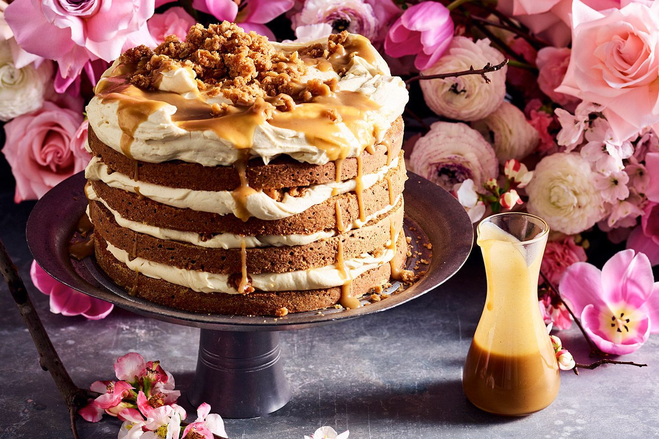

You can even take inspiration from the past. While Father’s Day officially dates back to 1508 and is based on the celebrations of the feast of Saint Joseph that started from the 14th century, the country that took it most seriously was Germany. Their Father’s Day was marked by all the blokes in the village filling a cart, the bollerwagen, up with beer, ham and sausages, and dragging it out by hand to the country for a picnic. So why not send him off to the golf course or the surf break with a ham sandwich and a couple of beers in his golf bag or three-board quiver. Just tell him it is tradition.

And while he’s gone, the kids can make him that schmaltzy card that’ll have him getting all misty-eyed, too.

# Why you should be drinking chilled red wine this summer (and all year long)



**Move over Aperol Spritz, there’s a new sheriff in town - and thy name is chilled red.**

An adage as old as the sands of time is that [red wine](https://www.delicious.com.au/drinks/gallery/eat-red-wine-easy-recipes-dinner-ideas/75euiiqs) should be enjoyed at room temperature. That might be all well and good with your bottle of vin de soif Loire Valley rouge on a cool, pleasant night in a Parisian wine bar, but we must play the hand we’ve been dealt.

The whole room temperature thing is quite literally medieval – think European castles made of stone and underground cellars – which simply doesn’t translate to our stuffy, poorly insulated homes on the other side of the globe.

The absolute last thing anyone should be drinking is a dad Shiraz at Australian room temperature on, well, let’s say most days.

It gets pretty hot around these parts, well over 20 degrees celsius on average (and then some in warmer months), guaranteeing you a big soupy mess, void of fruit, clarity, and freshness, dominated by its alcohol. Not every red should be served [fridge-cold](https://www.delicious.com.au/drinks/article/9-best-wine-fridges-top-rated-wine-coolers-fridges-2021/vnbeotdm), but it’s safe to say most (if not all) should see at least a few degrees taken off the top before you drink it – yes, even that cab sav would benefit from a quick visit to the old icebox.



***Related story:***[***We so want it to be true, but is red wine actually good for you?***](https://www.delicious.com.au/drinks/wine-champagne/article/red-wine-good-you/yphqlro5)

Reds specially built for the fridge are generally lighter, lower in alcohol and tannin, void of oak character and best consumed young – think bright, fruit-forward and juicy with refreshing acidity. Often these wines live somewhere between a rosé and light red, sometimes a blend of red and white grapes, and are usually not super serious, more thirst quenchers.

They fill a void that has long existed for red wine drinkers and provide an exciting alternative for the rosé crowd. Move over [Aperol Spritz](https://www.delicious.com.au/recipes/collections/gallery/aperol-spritz-cocktail-recipes/ewgfy91p), there’s a new sheriff in town – and thy name is chilled red.

While chilled red isn’t exactly a new discovery – the natural wine world has been all over this for years – it’s undoubtedly the next big thing. You know there’s an incoming trend when even the big guys jump on it (hello, Jacob’s Creek ‘Lively Bunch’).

I’d say chilled red is here for a good time and a long time. We’re simply better than a 15% alcohol Barossa shiraz on a hot summer’s day.

# Melissa Leong shares her 5 must-try food experiences in the Top End



Melissa Leong Darwin River Cruise. Source: Caroline McCredie

**Mel has done all the delicious research on the ground for us (tough gig!), and shortlisted the very best places to grab a bite in the NT.**

Melissa Leong is no stranger to travelling for good food. And her recent travels have taken her to Northern Territory, where she sampled the melting pot of South East Asian, South Asian and local Australian cuisine in a myriad of settings.

Here are her top five spots.

## ****Ella, by Minoli****

“Minoli is, hand on heart, one of the most talented cooks to come out of the MasterChef Australia kitchen during my time so far,” says Melissa of Minoli De Silva. “Her ability to translate her history and home to her food is truly magical, and I am just so happy to see her doing what she always dreamed she’d do.” A hidden haven in Darwin city, [Ella by Minoli](https://ellabyminoli.au/) is tucked away in a quieter pocket of the CBD. It opened its doors in May and has been showcasing seasonal, local Northern Territory produce combined with modern Sri Lankan flavours ever since.

“Anyone who understands [Sri Lankan](https://www.delicious.com.au/travel/international/gallery/sri-lanka-travel-guide/8jcl2pso) cuisine knows that a dish can be good, but it’s about how it all comes together and is shared, that matters most,” says Melissa. “To that end, it was wonderful to share the table with more than just one other person, so we could have an all out feast. To see some of the dishes she thought up on the spot in the MasterChef kitchen, evolve into a restaurant dish, is amazing. I particularly loved her curry leaf cured snapper, vibing with pops of finger lime, rich with coconut dressing and spiked with curry leaf oil. The crispy roast pumpkin isn’t just a vego token option either, it’s layered, textural and a wonderful spectrum of sweet, savoury and sour.”

## ****Tiwi Island Retreat****

Set amongst a pristine marine sanctuary, with contemporary beach shack vibes, [Tiwi Island Retreat](https://tiwiislandretreat.com.au/) is one of Australia’s premier barefoot destinations. Just a 30 minute light plane ride from Darwin and you will be transported to the exclusive beach front location, that makes for the perfect base to enjoy world-class fishing adventures, Indigenous culture tours and unique wildlife encounters. All of which Melissa rates as must-do experiences.

“We witnessed crocs, sharks and a couple of local river dolphins coexisting happily near the resort,” says Melissa. “We went [mud crabbing](https://www.delicious.com.au/recipes/mud-crab-curry/shu8ybu5) and fishing in the mangrove estuaries … I haven’t been fishing in years, and it was such a wonderful thing to jump in a tinny with our local guide Vince, crack a few ice cold beers in the heat, and throw a line out. I know it doesn’t really sound like something you’d catch me doing, but there is something deeply contemplating and relaxing about the simple repetition of casting and reeling that quietens my brain, while we listened to Vince tell us stories of the people and the place that we’re in. Being present is in short supply in my life at times, and this kind of activity really helps to reset that. Did I catch anything? Yes! A gold band snapper.”

Onsite, executive chef Travis Crane embraces the Top End’s Asian and Indigenous influence in his cooking that is accentuated by incredible Asian spices and bush tucker. All of which is served right on the sandy shores of the resort’s beach at sunset.

## ****Finnis River Lodge****

Finniss River Station has been running as a cattle station since 1987. But with the addition of a luxury lodge and infinity pool, paired with good food, the lodge has become a popular destination for foodies with a taste for luxury.

“If the infinity pool overlooking the lush green grassland of [Finniss River Lodge](https://finnissriverlodge.com.au/) wasn’t enough, the food really was amazing,” says Melissa. “It’s clear that chef Travis is inspired by the produce of this region, fusing it with a great sense of humour and considerable technical capability. I loved the perfectly executed lemon myrtle infused Basque cheesecake, there was also an elegant take on the pub classic parmie – made with crocodile, and [shakshuka eggs](https://www.delicious.com.au/recipes/shakshuka-date-preserved-lemon-saladrecipe/72vaw22g) bathing in a smoked tomatoey goodness”

***Related story:***[***Hayden Quinn dishes up a taste of the Red Centre***](https://www.delicious.com.au/travel/australia/article/hayden-quinn-takes-nt-taste-australia-season-3/izlss6e9)

It’s not all soaking in the infinity pool and indulging in delicious food at Finniss River Lodge. “It’s always a privilege to stay on someone’s expansive farm property and being so far away from everywhere,” says Melissa. “Staying on this working cattle station, a property that encapsulates extensive wetlands, bushland, grazing country and the coast, along with its array of fauna … the quiet is enveloping and welcoming. Taking an ATV out to the paddock at sunset and having canapes and Champagne with the cows and a handful of pampered ponies, was just the kind of animal therapy we needed.”

## ****Rapid Creek Markets****

If you know Melissa, you know how much she loves [Darwin’s Rapid Creek Markets](https://rapidcreekmarkets.com.au/). In fact, it’s one of her favourite markets in Australia. “The sheer variety and quality of tropical-leaning produce is amazing. My favourite time to go is just after dawn, while the air is still cool, and the world is just waking up. If you close your eyes, and just take in the smells and sounds, you are reminded that we are indeed part of Southeast Asia,” says Melissa.

“If you want access to incredible quality tropical produce with a Southeast Asian accent, you’d be hard pressed to find a better market. Haggle over plump, juicy mangoes, makrut lime leaves as long as your forearm, banana flowers, preserved eggs, or a fully stacked roti for breakfast after you’re done shopping, this market is Darwin in a warm, friendly nutshell. That’s my idea of a solid summer holiday.”

## ****Darwin Harbour Cruise****

There’s no better way to end a day in Darwin, than with a harbour cruise, and Melissa agrees. “If you really want a warm, glowy sunset over Darwin (and who doesn’t), then jump on a [Darwin Harbour Cruise](https://www.darwinharbourcruises.com.au/), head to the top deck and soak it up,” she says. “Book a table for a couple of friends and some sunset rosé and snacks to really make the most of golden hour with your best gals and guys. It’s really all about the antipasti platter and a bottle of something fizzy (beer or Prosecco) or pink (the aforementioned rosé).”

# From Market To Glass: How To Deseed Pomegranate And Make Its Juice

## Pomegranates are packed with antioxidants, fibre, unsaturated fats, Vitamin E, K and magnesium. Here's how to peel it and make juice from it!

Edited by Aditi Ahuja Updated: November 24, 2022 12:44 IST Read Time:2 min

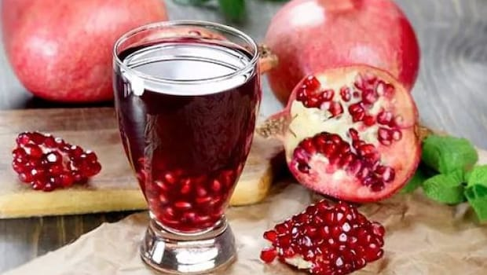

Pomegranate can be easily peeled and made into juice.Photo: iStock

### Highlights

* Pomegranate is a healthy and refreshing fruit
* This humble fruit can be peeled and enjoyed
* Here are chef Kunal Kapur's tips to make it

You must have often spotted an army of bright red pomegranates front-lining the fruit rack in the market. As if they are waiting for you to take them home. Who doesn't like to chomp on these tiny red jewels? Well, most people prefer to consume it in the form of juice. Pomegranate juice is certainly one of the most loved fruit juices as they are a treat to the soul. Pomegranates are packed with antioxidants, fibre, unsaturated fats, Vitamin E, Vitamin K and magnesium, hence they score high on the health quotient as well.

While it may be a task to deseed a pomegranate, making its juice is fairly easy. If you follow chef [Kunal Kapur's](https://food.ndtv.com/food-drinks/recipe-beat-the-heat-with-this-indulgent-kulfi-recipe-by-chef-kunal-kapur-2847090) method, you don't even need a juicer. The chef, in his Instagram post, has also shared a hassle-free way to deseed pomegranates. So, what are you waiting for? Get started now.

Sharing the tips, Kunal Kapur wrote, "Pomegranate is a fruit that contains antioxidants and anti-inflammatory substances. along with [Vitamin E](https://food.ndtv.com/food-drinks/how-to-make-ghevar-chef-kunal-kapur-shares-easy-recipe-3149819), K and Magnesium. Learn how to make simple juice out of it in minutes without any juicer."

## Steps To Deseed And Prepare A Glass Of Pomegranate Juice:

Step 1: First, chop off the flower from the top.

Step 2: Using a knife, score along these wider rib portions of the pomegranate. Make sure you cut through the red rind and most of the way through the white pith. P.S: Don't cut into the seeds or you will land in a [juicy mess](https://food.ndtv.com/food-drinks/wondering-how-to-make-perfect-icing-for-your-cake-kunal-kapur-shows-the-way-3255962).

Step 3: Crack it open and clean the thin white membranes which separate the ruby-red jewels.

Step 4: As you pick pomegranate seeds, keep throwing them in a bowl of water. Why? This is an easy peasy way to clean the fruit.

Step 5: Now empty the pomegranate in a [mixer](https://food.ndtv.com/food-drinks/want-to-make-a-delicious-paratha-with-ingredients-available-at-home-try-out-this-masala-lachha-paratha-2827899), and give it a grind.

Step 6: Strain the juice to remove the seeds. And, the task is done.

Pour the juice into a glass and relish.

# The REAL reason why most fast-food chains have red & yellow logos

# The REAL reason why most fast-food chains have red & yellow logos

#### TIMESOFINDIA.COM | Last updated on -Nov 22, 2022, 08:00 ISTShare [fbshare](javascript://)[twshare](javascript://)[pinshare](javascript://)Comments (0)

### 01/5Explained: The red & yellow coloured logo of fast food joints

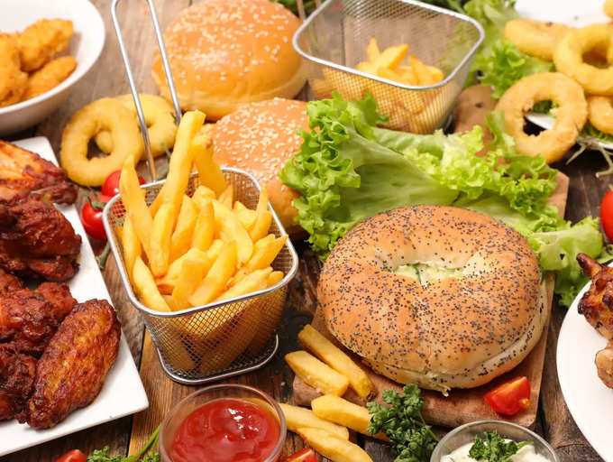

Let’s accept it, fast food is a part of our life. From burgers to fries, and crispy chicken to pizza, we love consuming all these junk foods from our favourite food joints. These foods are some of the most common ones that one can find across the world in all the fast food joints. However, it’s not just these, there is one more commonality in these joints. Wondering what it is? Well, it’s none other than the colour combinations used in the logos of these popular fast-food joints. If you have not thought about it, take a look once again. Most of these fast food chains have the same shade of yellow and red in their logos, and marketing experts say there's a very good psychological reason for that. (Images courtesy: Canva)

### 02/5Increases the appetite

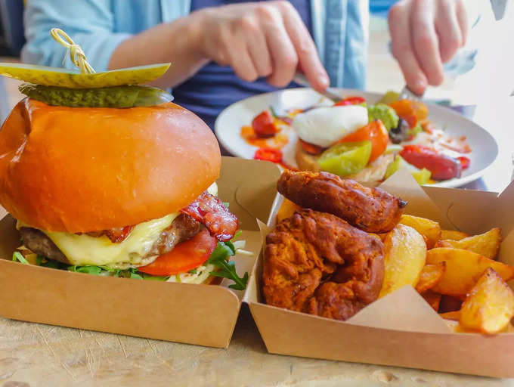

The basic reason behind these colour choices is that we tend to crave when we see these two colours together. It increases people’s appetite and this is the only reason why people tend to eat more in fast food joints than their actual hunger. And not just that, there is real psychology behind this theory. Read below to know more about it.

### 03/5The colour psychology



According to colour psychology, the colour yellow has long been associated with feelings of contentment, happiness, competence, and comfort. One simple colour is responsible for that sense of nostalgia and friendliness you feel whenever you pass by those golden arches.  
  
On the other hand, red is the colour that illustrates desire, power, and love. It's the reason when paired with yellow, a person might suddenly start salivating for a cup of perfectly cooked golden french fries.  
  
When it comes to red & yellow logos, it's said that red can make people hungry while yellow speeds up your metabolism.

### 04/5The scientific reason



According to science, red is the colour that is associated with being active and can also increase our heart rates. Looking at this colour also increases your heart rate and gives you an appetite. While the yellow colour is associated with happiness. Not just this but yellow colour is easy to spot even in bright daylight. That’s why using the yellow logo helps to easily get spotted, even from distance. According to various studies, half the time people order their food depending on the colour of the product alone. Experts believe that the combination of these two colours gives feelings and emotions that make people hungry.  
  
  
[READMORE](javascript://)

### 05/5Conclusion



Red makes you hungry while yellow makes you feel happy, which encourages you to buy food, even when you are not hungry. So if you think, it is just a coincidence that all the fast food chains have their logos painted in red and yellow. You are thinking wrong. There is a strong marketing strategy behind these coloured logos, which makes you eat more than the required amount resulting in obesity.